**POWERFUL CLI TOOL FOR API MIGRATION ACROSS MULTIPLE ENVIORNMENTS**

A. K. A. Perera (IT14121548)

G. L. A. K. N. Perera (IT14112706)

V. P. Wijayaweera (IT14106484)

M.A.M. Asbar Ali (IT14053788)

Bachelor of Science (Hons) in Information Technology

(Specializing in Software Engineering)

Department of Software Engineering

Sri Lanka Institute of Information Technology Sri Lanka

October 2017

**POWERFUL CLI TOOL FOR API MIGRATION ACROSS MULTIPLE ENVIORNMENTS**

A. K. A. Perera (IT14121548)

G. L. A. K. N. Perera (IT14112706)

V. P. Wijayaweera (IT14106484)

M.A.M. Asbar Ali (IT14053788)

Dissertation submitted in partial fulfillment of the requirements for the Bachelor of Science (honors) degree in IT (Specializing in Software Engineering))

Department of Software Engineering

Sri Lanka Institute of Information Technology

October 2017

**Declaration**

“We declare that this is our own work and this dissertation entitled “**POWERFUL CLI TOOL FOR API MIGRATION ACROSS MULTIPLE ENVIORNMENTS**”, does not incorporate without acknowledgement any material previously submitted for a Degree or Diploma in any other University or institute of higher learning and to the best of our knowledge and belief it does not contain any material previously published or written by another person except where the acknowledgement is made in the text. Also, I hereby grant to Sri Lanka Institute of Information Technology the nonexclusive right to reproduce and distribute our dissertation, in whole or in part in print, electronic or other medium. We retain the right to use this content in whole or part in future works (such as articles or books).

|  |  |  |
| --- | --- | --- |
| **Name** | **Student ID** | **Signature** |
| A.K.A. Perera | IT 14121548 |  |
| G. L. A. K. N. Perera | IT 14112706 |  |
| V. P. Wijayaweera | IT 14106484 |  |
| M. A. M. Asbar Ali | IT 14053788 |  |

The above candidate has carried out research for the B.Sc. Dissertation under my supervision.

….…………………………. ….………………………….

Signature of the supervisor: Date

**Abstract**

.

Development organization maintain separate environments for development, quality assurance and production etc. These environments execute independently and have their own deployments and own methods of traffics controlling that are handle locally. Under such a process Application programming interface(API) artifacts allowed to be created only at development environment, tested in QA environment and then would promoted to the production environment prior releasing to the market. When moving API management products from one environment to another all the created APIs need to migrate across different environments to test the exact functionality and behavior of the application. Purpose of this implemented tool is to minimize the effort and time in re-creating APIs and facilitate the accurate and efficient migration across different environments without any major post migration changes and additional effort. Most of the API managing products as well as API publishers engaging with API imports and exports of APIs will be the beneficiary parties of this product. Firm analysis of the current migration techniques uses by trending API Management products reveled major sieve point that needed to be address.

Final tool will be an executable file which can be plug and play via the command line interface. This tool can be use by any REST based API managing applications without major configuration changes. Other than import and export functionality, tool equipped with built-in authentication mechanism to ensure the security of the publisher proprietary of the APIs, API subscription and single cluster deployment via minikube and google cloud

**Acknowledgement**

We would like to take this opportunity to express my sincere gratitude and profound feeling of admiration to the project supervisor, Mr. Anuradha Jayakody for his meticulous guidance and immense support throughout the project duration. We greatly indebted to him for his effort and motivation which lead us to the success where we are.

We would like to thank Mr. Jayantha Amararachchi, the lecture-in-charge of module CDAP for the continuous guidance given in finishing an industry standard outcome. Our special thanks to Sri Lanka Institute of Information Technology for giving us the opportunity to carry out this research project.

Our sincerely thank goes to team API manager at WSO2, who helped in gathering relevant information related to the application. Also, we would like to thank our colleagues who gave us support in several aspects to success this research project in better way. Last but not least, we thank all those who like to remain anonymous although, the help provided us was valuable.

Table of Contents

Declaration i

Abstract ii

List of Figures vii

List of Tables ix

List of Abbreviations x

1 INTRODUCTION 1

1.1 Problem to be Addressed 3

1.1.1 Additional developer effort requires in recreating the same API in different environments. 3

1.1.2 Extra time spends on recreating APIs 3

1.1.3 Loss of actual functionality and features. 4

1.1.4 Individual components should be deployed separately. 4

1.1.5 Poor authentication mechanisms lead to unauthorized access 4

1.1.6 Absence of the functionality of API Subscription causes leak to the confidential information 5

1.2 Background Context (Literature Review) 6

1.3 Research Gap and Research Question 12

2 METHODOLOGY 15

2.1 Addressing the Literature 15

2.2 Agile Methodology 17

2.3 Software Development Methodology 20

2.3.1 Feasibility study 20

2.3.2 Requirement analysis and specification 21

2.3.3 Design 21

2.3.4 Testing and implementation 24

2.4 Research Methodology. 25

2.4.1 Authentication mechanism 25

2.4.2 API export 28

2.4.3 API import 31

2.4.4 API subscription 35

2.4.5 Deploying APIs through kubernetes 38

2.4.6 Automation of migration with docker 39

2.5 Research Findings 42

3 RESULTS AND DISCUSSION 45

3.1 Evidence 47

3.1.1 Authentication mechanism and access token generation 47

3.1.2 API export 48

3.1.3 API import 51

3.1.4 API subscription 54

3.1.5 Single cluster deployment in minikube. 61

3.1.6 Google container engine cluster deployment. 64

3.2 Discussion 65

3.2.1 System performance 67

3.2.2 System interfaces 67

3.2.3 User interfaces 68

3.2.4 Hardware interfaces 68

3.2.5 Software interfaces 68

3.2.6 Communication interfaces 69

3.2.7 Memory constraints 69

3.2.8 Site adaptation requirements 69

3.2.9 Constraints 70

3.2.10 Assumptions and dependencies 71

4 CONCLUSION 72

5 References 74

6 Appendices 80

6.1 Appendix – A: Gantt Chart 80

6.2 Appendix – B: Work Breakdown Structure 81

6.3 Appendix – C: Feedback by industry experts 82

6.4 Appendix – D: Sequence Diagrams 83

6.4.1 Overall sequence diagram for the system 83

6.4.2 Sequence diagram for import functionality 84

6.4.3 Sequence diagram fragment for export functionality. 85

6.5 Appendix – E: Class Diagram for the overall system 86

6.6 Appendix – F: Activity Diagram for the overall system 87

SUMMARY 88

# List of Figures

Figure 1.1 Basic functionalities expose by a typical API managing application 1

Figure 1.2 Migration of APIs across different environments 2

Figure 1.3 Trending API Managing applications in the current market. 6

Figure 1.4 Market Impact of 2016-2017 of leading API Management Vendors 7

Figure 1.5 Comparison between popular API managing applications based on the availability of API migration functionality 8

Figure 2.1 Agile Methodology overview 17

Figure 2.2 Comparison between traditional and continuous Analysis, design, coding, and testing in agile methodology 18

Figure 2.3 General workflow of the CLI tool 22

Figure 2.4 High-level architectural diagram of the CLI tool for API migration 23

Figure 2.5 Proposed authentication mechanism of the CLI tool 26

Figure 2.6 Authentication mechanism of the CLI tool 27

Figure 2.7 Flow of API Export Functionality 28

Figure 2.8 Overview of API export functionality of the CLI tool 29

Figure 2.9 File structure of the portable API archive 30

Figure 2.10 Flow chart of the API import functionality 32

Figure 2.11 Workflow of the API import functionality 33

Figure 2.13 Flow chart of the API subscription functionality 35

Figure 2.14 Overview of API subscription 36

Figure 2.15 Code flow of docker in CLI tool 41

Figure 2.16 Work flow of the docker in CLI tool 42

Figure 3.1 Functional comparison between our CLI tool for API migration and few trending migration tools in current industry 46

Figure 3.2 System login 47

Figure 3.3: Encoded User Credentials 47

Figure 3.4: Main functionalities 48

Figure 3.5 Interface of Basic authentication 48

Figure 3.6 Select options to proceed 48

Figure 3.7 provide the path of CSV file 49

Figure 3.8 All API Identifiers 49

Figure 3.9 Created archive folder 50

Figure 3.10 Original imported environment 51

Figure 3.11 Option list by the CLI tool 51

Figure 3.12 File path to the archive folder 52

Figure 3.13 Successfully imported APIs 52

Figure 3.14 Destination environment after bulk API import 53

Figure 3.15: Main functionalities 54

Figure 3.16: Sub functionalities of API Subscription 54

Figure 3.17: Example generated access token for subscribe scope 54

Figure 3.18: Details required when adding a new subscription 55

Figure 3.19: Creating a new application 55

Figure 3.20: Interface of after successfully adding a subscription 56

Figure 3.21: Applications available in API store 57

Figure 3.22: Details of the created application 57

Figure 3.23: Subscriptions for the application 58

Figure 3.24 List subscription details by API 58

Figure 3.25 Subscription details by an application 59

Figure 3.26 Selecting an application to unsubscribe an API 59

Figure 3.27 List of APIs subscribed by application 60

Figure 3.28 Selecting an API to unsubscribe. 60

Figure 3.29 Minikube Cluster Deployment 61

Figure 3.30 Minikube Scaled Deployment 62

Figure 3.31 Showing the before rolling update get request 62

Figure 3.32 After the update get request 63

Figure 3.33 Google Container Engine Deployment 64

Figure 3.34 Get request to the container 64

# List of Tables

Table 1.1 API migration mechanisms followed by different API managing products 9

Table 2.1 Archive folder entries 31

# List of Abbreviations

|  |  |
| --- | --- |
| **Abbreviation** | **Description** |
| API. | Application Programming Interface |
| APIM. | API Manager |
| AWS. | Amazon Web Services |
| CLI. | Command Line Interface |
| CSV file. | Comma-Separated values file |
| Dev. | Development |
| GKE. | Google Container Engine |
| Http. | Hyper Text Transfer Protocol |
| JSON. | JavaScript Object Notation |
| JVM. | Java Virtual Machine |
| JWT. | JSON Web Token |
| OAuth | Open Authorization |
| OS | Operating System |
| QA. | Quality Assurance |
| REST. | Representational state transfer |
| SSL. | Secure Socket Layer |
| UI. | User Interface |
| UUID. | Universally Unique Identifier |
| WSDL. | Web Services Definition Language |
| XML. | EXtensible Markup Language |
| YAML. | Yet Another Markup Language |

# INTRODUCTION

API management is the process managing activities related to API creating, publishing, monitoring and life cycle management of the APIs [1]. There are several commercially available as well as open source products standardize this management activity. Typical API management software allows API publishers to design APIs and publish those in the API store. API store allows API publishers to advertise their APIs. API subscribers can discover APIs and read the documentation and forums, rate/comment on the APIs, subscribes to APIs, obtain access tokens and invoke the APIs [2]. Figure [1.1] shows the basic functionality expose by a typical API managing application.

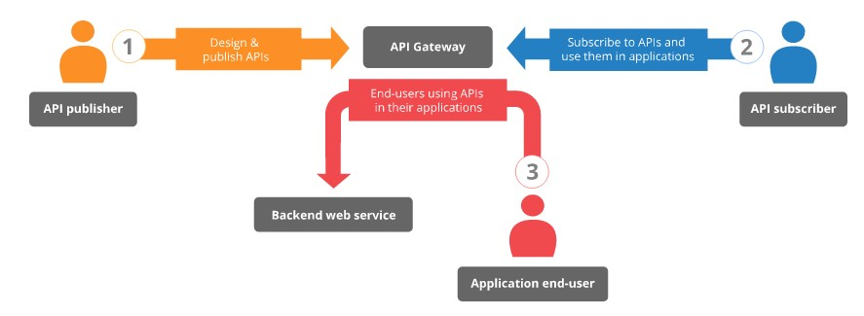

Figure 1.1 Basic functionalities expose by a typical API managing application

Before such a product been released in-to the market, it traverses through different environments with in the organization as Dev (Development), QA (Quality Assurance) and production to verify the product is ready to release. Each environment has different set of stakeholders that have access only to their own environment [1]. API management across isolated environments has their own deployment and own methods of traffics controlling that handle locally. While the product been proceeding at various environments, all the APIs created in one environment should be passed in-to another to examine the expected functionality and behavior of the applications uniquely across several environments. Usually transportation of created APIs along with the product is not possible since the APIs are not a part of database and neither a part of the code base. But manual re-creation of the set of APIs in several environments causes number of developer-wise as well as organizational-wise problems. Therefore, APIs created in a one environment needed to be migrated in to other environments to maintain a constant pre-marketing state of a product. Figure [1.2] shows how the API migration take place between several environments in a developing organization.

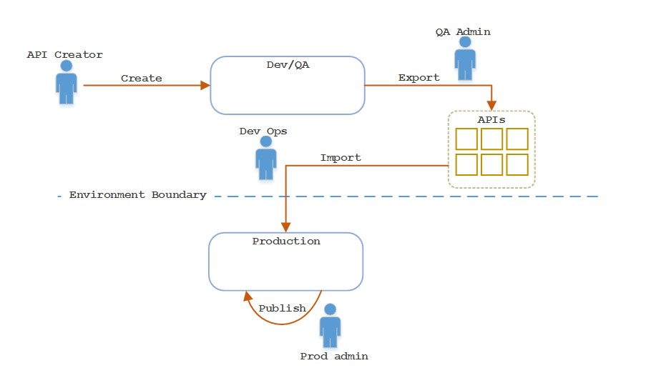

Figure 1.2 Migration of APIs across different environments

API migration comprises of two key processors as exporting and importing. Exporting refers to moving of APIs from one environment to another and import refers to receiving APIs in-to a new destination environment. Export of APIs involves in retrieving all the API resources including API definitions, swagger definitions, thumbnails, WSDLs and documentations to another environment. During the process of API import, should be able to rebuild the API using the received API resources. Therefore, it requires a mechanism to automate the process of API migration among different environments on behalf of the excessive manual work.

## Problem to be Addressed

To test the API manager product during each stage of pre- marketing process consistent background environments needed to be maintained. Therefore, developers try to re- create these APIs in a new environment. When there’s no any clear defined mechanism to export and import the APIs created in the past environments, Developers has to set up and publish these APIs in the new environment manually. Manual creation of APIs causes several identified issues as below [3].

### Additional developer effort requires in recreating the same API in different environments.

Creating an API with minimal features in single given environment cost average of 2 minutes. Number of such APIs are created in the process of developing some API management products as WSO2 API manager, Apigee etc. re- creating these APIs in several other environments is a wastage of developer productive time.

### Extra time spends on recreating APIs

Time taken in manual API recreation will drag the test schedules and thereby extend the final release days of the product. Further, it is a waste of productive time that can be used in any feature development tasks. As well as this is critical considered to the product’s time-to-market. Gradually credibility of the product will reduce implicitly.

### Loss of actual functionality and features.

Even though the developers somehow manage to create the APIs in the new environments, some of the functionalities and the features need to be tested can be missed due to the lack of knowledge about the functionalities expose by the application or due to human errors. In that case developers must re-create a similar API with missed functionalities to edit the existing before proceeding.

### Individual components should be deployed separately.

Single API consist of many components as API definitions, swagger definitions, API thumbnails, documentation, WSDL and any migration policy sequences. In most of the migration tools each of these components needed to be deployed separately during the process of importing API to a new environment. This has a considerable effect on the performance of the migration process. In the process of bulk import and export this manual work increase in multiple times as per to a single API import and export. Ultimately, it’s a waste of productive developer effort and time.

### Poor authentication mechanisms lead to unauthorized access

Authentication mechanism of most of the tools does not have a better built in mechanism for the authentication. In a developing organization, the information should be in more secured since the data should not be accessible by unauthorized users. The authentication process of most of the current available tools relies on third party integrations and simultaneously need to contact third party each time an authentication request occurs. It will lead to unauthorized accesses.

### Absence of the functionality of API Subscription causes leak to the confidential information

When invoking APIs to an application the invocation should also authenticate to prevent unauthorized access and to avoid leaking of the information unauthorized persons. Otherwise the chance of accessing confidential information in the application by intruders is high.

## Background Context (Literature Review)

There are number of commercially available as well as open source API Managing products available in the current market. Figure [1.3] shows most popular API managing application vendors in current industry [2].

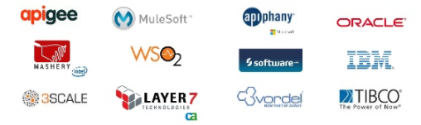

Figure 1.3 Trending API Managing applications in the current market [4].

Nowadays, API’s are powering a huge transformation across industries. The growth of API’s is increasing day by day all around the world and it is being an enormous impacted of organizations growth and productivity [5]. Researches says, companies that adopt APIs have an increase in sales, net income and market capitalization [6] [7]. Figure [1.4] shows market impact of leading API management vendors from 2016-2017 [8] [9].

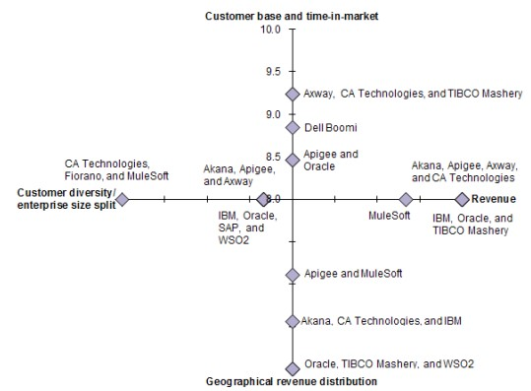

Figure 1.4 Market Impact of 2016-2017 of leading API Management Vendors [10]

Although there are vast number of API managing applications available in the market few out of them have defined a partial or complete mechanism to migrate the APIs across different organizational environments. Out of those applications with API migration mechanism, only few products use CLI (Command Line Interface) tools to fulfil the above requirement. Figure [1.5] shows a visual indication of comparison between API managing applications based on the availability of defined mechanism for API migration [11].

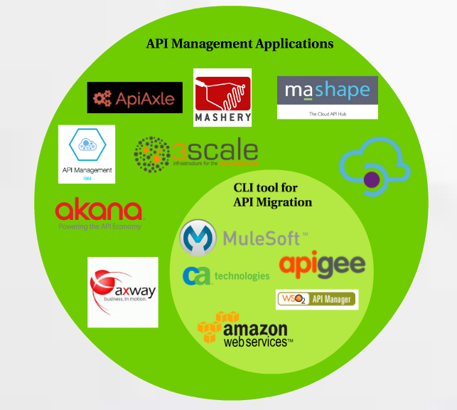

Figure 1.5 Comparison between popular API managing applications based on the availability of API migration functionality

These API managing applications with API migration functionality follows different methodologies to export an API from one organizational environment to another environment. Most of the RESTful APIM applications use curl commands to retrieve API components including thumbnails, API definitions, swagger definitions, documentations and mediation policies etc. Some tools use message formats as JSON and XML to store the content of API components.

Table [1.1] represent the API migration methodologies followed by few such trending products in the market.

Table 1.1 API migration mechanisms followed by different API managing products

|  |  |
| --- | --- |
| Apigee | CLI tool built on NodeJs thatleverages **t**he JSON request structureused by Apigee Management APIs [12]**.** |
| Mule Soft | 1. Create a properties file for each environment. 2. Configure a property placeholder in your application to look for the deployment environment upon launch. 3. Configure an environment variable to point to a specific environment during application deployment [13] [14]. |
| WSO2 | Provides RESTful (Representational state transfer) API which can be used to import/export registry resources and meta information for a particular API. This can be access by deploying the WSO2 import/export tool which is a WAR file [15]. |
| AWS | AWS CLI built using python and uses SSL (Secure Sockets Layer) when communicating with AWS services. For each SSL connection, the AWS CLI will verify SSL certificates. This option overrides the default behavior of verifying SSL certificates [16]. |
| CA Technologies | CLI tool built in java and built on top of the existing REST-Management API which uses JSON web tokens (JWT) in the API gateway [17]. |

API migration is not a simple task where developers can develop and continue using. There are many constraints and limitations that constrict the migration of APIs across environments. Several researches have been done to identify these factors.

According to researchers, they have found some challenges of web API migration [18]. Those are,

* Transformation between JSON and XML: Organize of the data, since web APIs usually provides data services other than function services.
* M to N Mapping: when multiple API invocations are required for one task the network latency will become high since API needs to access the web servers for invocations.
* Delete Method: Developers could not access the deleted methods once an old version of an API shut down after a certain period.
* Authorization Protocol Change: All API invocations needed to be change in the consumer’s side when the authorization protocol upgraded.
* Rate limit: Some of the API providers frequently add a limit to the rate for the services and the client programs which were invoked the API are also needed to be change.
* Authorization of API Access
* APIs are usually backward-incompatible: When updating, the client applications may cause to fail [19].

After in-depth analysis done on these different mechanisms of API migration, we could find out diverse set of drawbacks that are shown by these products commonly. Those can be listed as follows.

* Delegation of key security functions to third parties.
* Individual components should be deploying separately.
* Limited developer portal functionality.
* Developer portals lack of automation features.

Further, we found the power of OAuth 2.0 in authenticating the proprietary web resources. During the literature review found that this is the based authentication technology use by most of the API managing applications. One of the potential benefits of OAuth 2.0 is the ability for users to share verifiable assertions about themselves without having to release any personally identifiable information.

As shown in the Table 1.2 most of the currently available tools contain OAuth 2.0 endpoints. Therefore, the introduced authentication mechanism in the proposed CLI tool can be used for many APIM application by different vendors. As a result, using a single authentication mechanism leads to make the proposed CLI Tool a generalized tool which can be used by different APIM applications [20]- [21].

Table 1.2 API managing applications support OAuth 2.0

|  |  |  |  |
| --- | --- | --- | --- |
| **APIM vendor** | **Available CLI Tool** | **Available CLI Tool for API Migration** | **Available OAuth 2.0 authentication endpoint** |
| WSO2 | Yes | Yes (Have to recreate) | Yes |
| Azure | No | No | Yes |
| IBM | Yes | No | Yes |
| 3scale | No | No | Yes |
| Apigee | Yes | Yes (Must recreate) | Yes |

## Research Gap and Research Question

There are number of commercially available as well as open source API Managing products available in the current market. Only few out of them have defined a partial or complete mechanism to migrate the APIs across environments. Out of them very fewer number of products have implemented a CLI (Command Line Interface) tool to fulfil the above requirement [22].

Even though these API managing products have define certain methodologies to perform export and import of APIs there are few drawbacks that can be addressed to optimize the performance of the process API migration.

All these currently available tools are platform dependent. Above stated tools can only be used within the specific API managing product which they built for and will have some dependencies on the platform they built on [23]. Therefore, platform dependency and application dependency was one of the major research questions needed to be addressed [24]. Most of all the import/export processed only confined to the product which they been built for. One process or tool of a one application cannot be used in any other application to acquire the same functionality. This is because backend implementation of the tool is highly depending on the interior architecture of the application implementation.

Delegation of major key security functions to third parties is another drawback that is common to above API migration mechanisms. Most of the current migration tools rely on third party integrations to perform security functionalities directly on behalf of them [25]. The trust relationship between the third-party application and the operating application is the foundation of this bond. APIs are proprietary properties [26]. Therefore, security becomes a key factor that needs to address in advance. Sometimes this trust relationship can be broken and application can be open to intruders, therefore in order to withstand this circumvent alternative security mechanisms or stronger authentication techniques should be integrated into the tool [25].

Another fact which is common to above methodologies is lack of more automated features [3]. Developers face higher burden in executing each step required for import or export of APIs. Developer portal functionalities that are can be execute via the CLI tool resides in a lower degree. Hence the performance of these tools is still at a lower degree which can be further increased by increasing developer portal functionalities expose by the migration tool.

Extensive developer portal functionalities are another question need to be address to achieve higher performance. Even though many APIM (Application Programming Interface Management) applications have define mechanisms for migration still it’s not fully automated since most of the execution and deployment processed need to be triggered by the developer manually. Since, there’s no big gap between manual process and migration mechanisms.

Furthermore, in most of the current processes individual components should be deployed separately. This is another research problem that can be address and thereby increase the efficiency and performance of the mechanisms. Generally, APIs composed of number of components as API definitions, swagger definitions, API thumbnails, documentation, WSDL and any migration policy sequences. In most of the migration tools each of these components needed to be deployed separately. This is a major fact affecting time for migration. In the procedure of bulk import and export this manual work increases by multiple times as per to a single API import and export. Ultimately, it’s a waste of productive developer effort and time.

Another fact is when retrieve APIs from the registry, response time should be minimum to retrieve APIs whether it is bulk or single APIs. Moreover, API size will depend on user’s requirement related to APIs but CLI tool will identify whether those APIs are single or bulk APIs and handle them individually. Through the CLI tool need to deploy the API for any type of scenarios in more efficient way, but current RESTful API based tools are sending high number of REST call for a single API export to retrieve the resources from data sources. At the same time, same number of APIs will be invoke for single API import. When come to the bulk import and export these numbers increase in multiples. This has resulted in several issues in performance and reliability. However, need to handle above tasks with minimum number of REST calls which will reduce both client & server errors. It may increase the efficiency and reliability of the CLI tool as well.

Moreover, there should be a proper way of invoking the created APIs in the environment. As well as it should be an authenticated way to avoid unauthorized access by intruders. API Subscription functionality does it to be achieved. It enables to generate access tokens and to authenticate the invocation of APIs. All these current API migration tools doesn’t have the support to perform API subscription via the migration mechanism which also has a market value in developing industry. Hence the developers have to move in to the manual mode and copy the API subscriptions after the migration process. The proposed CLI Tool has introduced the API Subscription functionality in an efficient way to receive access tokens and to be authenticated to invoke the APIs.

Considering these drawback in currently available API migration mechanisms, intention of our CLI tool is to overcome this technical and functional gap and mean while forward a powerful, generalize CLI tool that could perform API migration across different environments efficiently.

Cloud computing is one of the major trending technology today. Deploying the API products in the cloud can streamline the moving of APIM application across different environment within the organizational structure.

# METHODOLOGY

## Addressing the Literature

Considering the above-mentioned research gap, we have come up with a software solution named ‘Powerful CLI tool for API Migration across multiple environments’ which will be a tool execute via command line interface, having capability to migrate a single or bundle of APIs across different environments within the development organizations. The CLI tool will minimize the effort and time in re-creating APIs when product moves between environments as Dev to QA or QA to production. This can minimize the additional effort and time required in regenerating the APIs in a different environment during APIM product migration cycle. Final software product will be an executable file that can be run via the command line interface together with the arguments including the details of the API/APIs need to export/export.

Tool comprised of several major key functionalities including built-in authentication mechanism, export of single and multiple APIs, import of APIs, API deployment in the google cloud using docker and kubernetes.

This tool is a generalized CLI tool, such that it can be used by number of APIM products with lesser pre- deploy configurations, that can be used in different API management application by different vendors. Another main benefit of the proposed tool is, the tool will be a platform independent tool which can be used in different operating systems. Implemented CLI tool will be run on any environment and within any API Managing applications.

Further this tool has addressed the issues in delegation of security functionalities to third parties which is a common fatal issue in currently available tools [3]. Security been ensured by applying two related technology, which are acting on top of the other. Following are the functionalities exposed by the API migration tool implemented by us.

1. Implement a built in basic authentication mechanism
2. Ensure the security through OAuth2.0 authentication
3. Export APIs from one environment and import to another
4. Deploying APIs and APIM product through docker and kubernetes
5. Create and publish APIs in new environments
6. Handling API migration through the CLI tool

## Agile Methodology

Agile methodology was followed in developing the software product. According to the agile methodology final product is followed by number of successive iterations. It is a time boxed, iterative approach of developing instead of trying to delivery all at once at the end. This methodology breaks down the project in to smaller functional units knows as user stories and depending on the prioritization delivering those in short life cycles called iterations. Depending on the feedback on each delivery we introduced changes to the product on the go. Figure [2.1] shows an overview of the agile methodology.

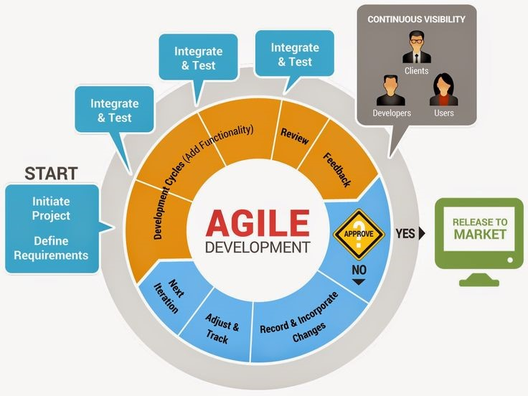

Figure 2.1 Agile Methodology overview [27]

*Source: Snyxius - How to implement an agile development process in easy steps*

According to the agile process there aren’t any clear-cut points for the end of analysis, design, coding and testing phases. Figure [2.2] shows the difference between analysis, design, coding and testing between traditional approach and agile methodology. As far as the project continue iterations these phases are repeated. It is easy to change the original plan according to the requirements arises on the development. This is known as ‘adaptive planning’.

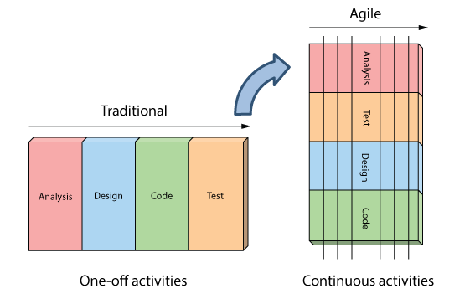

Figure 2.2 Comparison between traditional and continuous Analysis, design, coding, and testing in agile methodology [28]

*Source: Agile in a Nutshell - How is Agile different?*

Reasons to choose agile methodology,

* High product quality
* Increased project control
* Reduced risk in failing
* Early and predictable delivery hence ability to gather feedbacks at the early phase of the software development.
* Supports changing requirements and easiness to manage the changes
* Testing and debugging during smaller iteration is easy.
* Easy to predict the risks and manage them

## Software Development Methodology

### Feasibility study

Our research topic was driven by the project proposal forward by WSO2 to the Google summer of code 2017. Going along with it we planned to develop it as a generalized tool that can be used by any API managing applications to perform API migration across different environments. Firstly, we did a thorough literature survey on migration mechanisms followed by trending API managing applications in the market. Then we identified the strengths and weaknesses exhibit by those products. Such identified drawbacks are mentioned before under the section research gap. After that we did a quick survey on challenges we might face upon addressing those identified drawbacks. Following are such challenges we revealed in the research.

* APIs been back-ward incompatible.
* Rate limit
* Authorization protocol changes
* Transformation between different message structures (eg. From JSON to XML)

Then we did a market analysis and selected an open source API managing application to observe the code base and behavior of such application. Four weeks study curve was allocated to observe the source code and behavior of an such application to come with a high-level design.

### Requirement analysis and specification

At the end of the learning curve, based on the literature survey we identified key functionalities that need to be addressed in the new tool to perform platform independent API migration. All these functionalities identified are not specific to any API managing application but common to all the API managing applications to deliver its intended functionality to the users. Following are the list of requirements that are identified to be included in the CLI tool implementing.

* Mechanism to enhance the security functionalities of the tool via key generation.
* Exporting and packaging of single/multiple APIs from one environment.
* Importing multiple APIs to a new environment and deploying in the publisher
* Supporting application generation and API subscription via a CLI tool.
* Single cluster deployment using minikube.
* Deployment of API managing applications in google cloud using docker and kubernetes.

### Design

After a well-organized feasibility study and requirement gathering we came up with detailed description for the system design that includes every main processes and sub processes, correct flow of the component and how individual component join with other components. After completing the Requirement analysis and specification phase, implemented the design phase. Now everyone in the team has a proper understand what is going on with their component including main and sub processes. By using the gathered knowledge, designed the following listed below,

* ER/EER diagrams
* Class diagram
* Use case diagrams
* Use case scenarios
* Business rules / application logics
* Sequence diagram
* Gantt chart

During the API export user can execute the tool with details of the APIs need to be export. Tool itself will authenticate the user with inbuilt basic authentication mechanism and with third party OAuth2.0 protocol. After authentication, tool itself will call the REST APIs and retrieve all the components related to exporting APIs form the data sources and compressed in to a transportable file. During the migration file created file can be transported and deploy to a new location through docker and kubernetes.

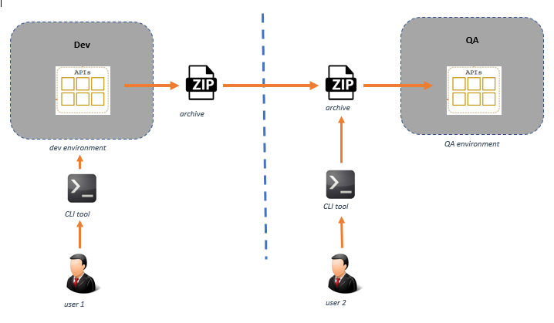API import functionality can be triggered by executing the tool with the imported file location as the argument. Tool itself will extract the content in the imported file and store API components in the data sources of the new location by invoking available REST APIs. Finally, the imported API will create in the new environment. General workflow of the CLI tool will be as shown in figure [2.3] below.

Figure 2.3 General workflow of the CLI tool

Interiorly this diagram can be decomposed in to several detailed high-level diagrams which will shows the REST API invocations and internal data flows back and forth. Processes running in the background may include activities related to key generation, bundling up API components, file transferring, extracting content and publishing imported APIs in new environments. Figure [2.4] shows a high-level architectural diagram of the implemented CLI tool.

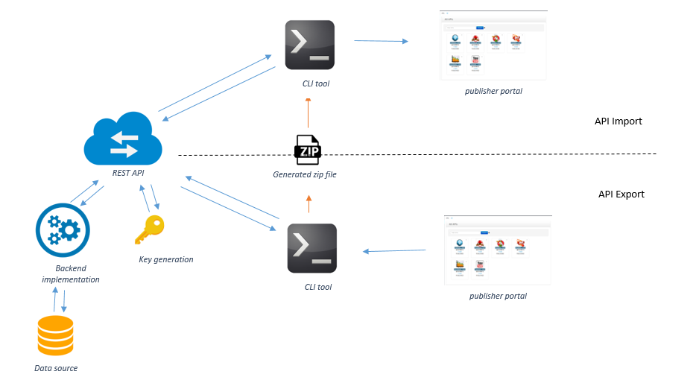

Figure 2.4 High-level architectural diagram of the CLI tool for API migration

### Testing and implementation

Testing any product is important before it’s been released in to the market because human mistakes are common in at all the time. In the agile methodology, testing can be done in several phases of the development. Testing ensure that the product is behave according to the expected behavior. This will ensure the Customer’s reliability and their satisfaction in the application. Each component of the CLI tool was unit tested by us at the end of each iteration and product present to 10 industry experts to collect feedbacks on the tool. Depending on the suggestions and improvements collected during the feedback session tool was fine tune to for optimal user interactions.

## Research Methodology.

### Authentication mechanism

APIs are proprietary resources. Therefore, initially CLI tool should be able to validate the user before continuing with the functionalities provided by the tool. The CLI tool equipped with a built-in authentication mechanism is to ensure a strong secure authentication process. Therefore, it has minimized the dependencies with external third-party authentication mechanisms. This will be achieving through basic authentication mechanism. Basic auth used because it’s the simplest mechanism that can be used to enforce access controls to web resources.

Furthermore, REST API calls should secure with authentication headers. OAuth 2.0 will be used as authorization protocol [27]. Since most of the available APIM applications use OAuth 2.0 as the authentication process, OAuth 2.0 tokens were used to generate the access tokens. To generate access token the retrieved client ID and the client secrete keys from the authentication endpoint after validating the user are required. The tool will set a one string contains clientID and the client secret separated by a colon (clientID:clientsecret). Then the tool will encode the string into a Base64 string since it is required to send to OAuth 2.0 authentication endpoint to generate an access token. Moreover, this access token from the OAuth 2.0 has a scope, which delimits what the access token can do and what resources it can be accessed [28] [29]. Therefore, the relevant OAuth scope also required to send into the OAuth 2.0 authentication endpoint. After send the string into to the endpoint, it will validate the string and if it is a valid one the generated access token can be retrieved from the authentication endpoint. This access token required for the REST calls which are for the further functionalities in the CLI Tool. Figure [2.5] shows the API invocations take place between CLI tool and the endpoints to validate the logged in user.

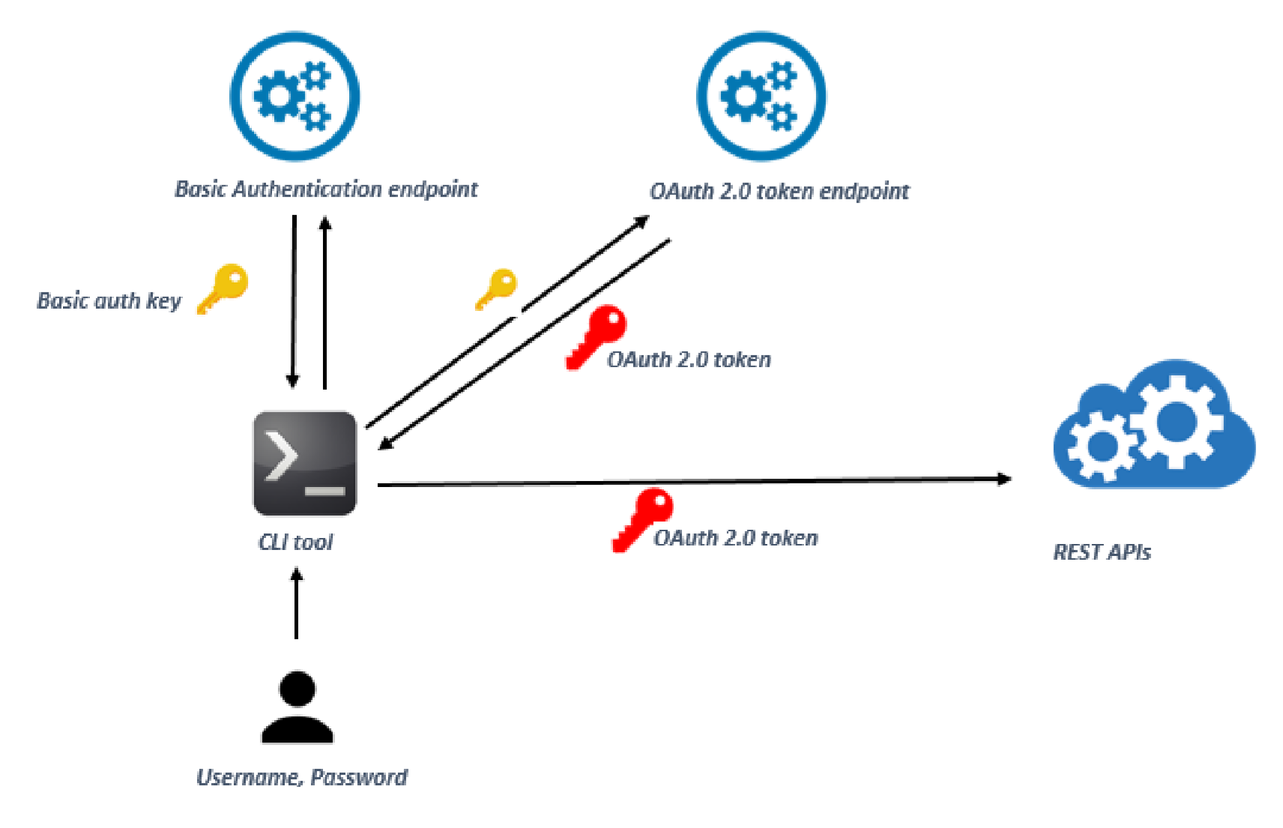

Figure 2.5 Proposed authentication mechanism of the CLI tool

Encapsulated authentication operations are undertaken to prevent any unnecessary external intruder actions. Figure [2.6] provides the detailed flow of the authentication mechanism followed by the CLI tool. The user can log in to the tool using a valid username and a password. This user credentials, decide about the environments that the user can access. Valid user name and a password then concatenated and encrypted is sent to the basic token endpoint. The basic token endpoint will issue a basic token with an expiration period. This encrypted basic token can then be sent in to an OAuth 2.0 endpoint which will return a valid OAuth 2.0 token. OAuth token is used by the CLI tool to call the REST API endpoints to retrieve the resource components of the APIs. These components can then be bundled and sent to the next environment.

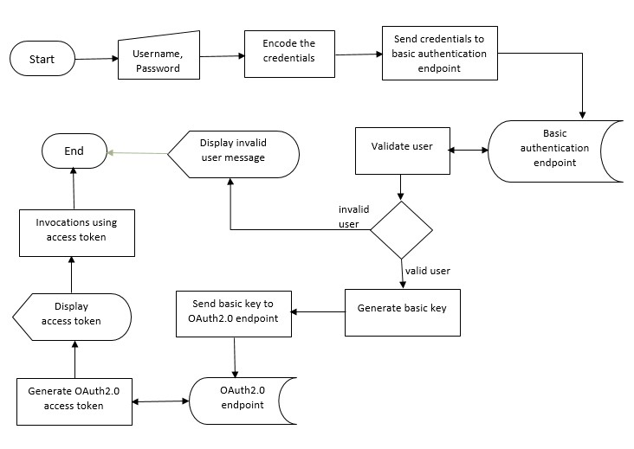

Figure 2.6 Authentication mechanism of the CLI tool

### API export

API is a collection of related resources. These resources include, API definition, swagger definition, thumbnail, documentations, WSDLs and mediation sequences. In API export Component, need to retrieve all the artifacts related to an API such as API definition, swagger definition, documentation and then bundle them up to a transportable file is referred to as API export. Figure [2.7] illustrates the process followed by the CLI tool which performs the above functionality.

At the initial, User can execute the tool with the credentials of the API details. API details can either be the Universally Unique Identifier (UUID) of the API or combination of API name, version and the owner of the API. Once the request has been sent, CLI tool search for the API in the API store. If it is a valid API, the CLI tool will retrieve all the artifacts related to the API separately, from the persistent data source and write them in a folder component belonging to API includes API definition,

Swagger definition, thumbnail images, mediation policies, documentations and any WSDLs if available. Finally, the created API will be compressed and converted into a transportable file, which can be used in the API import process at the receiving end.

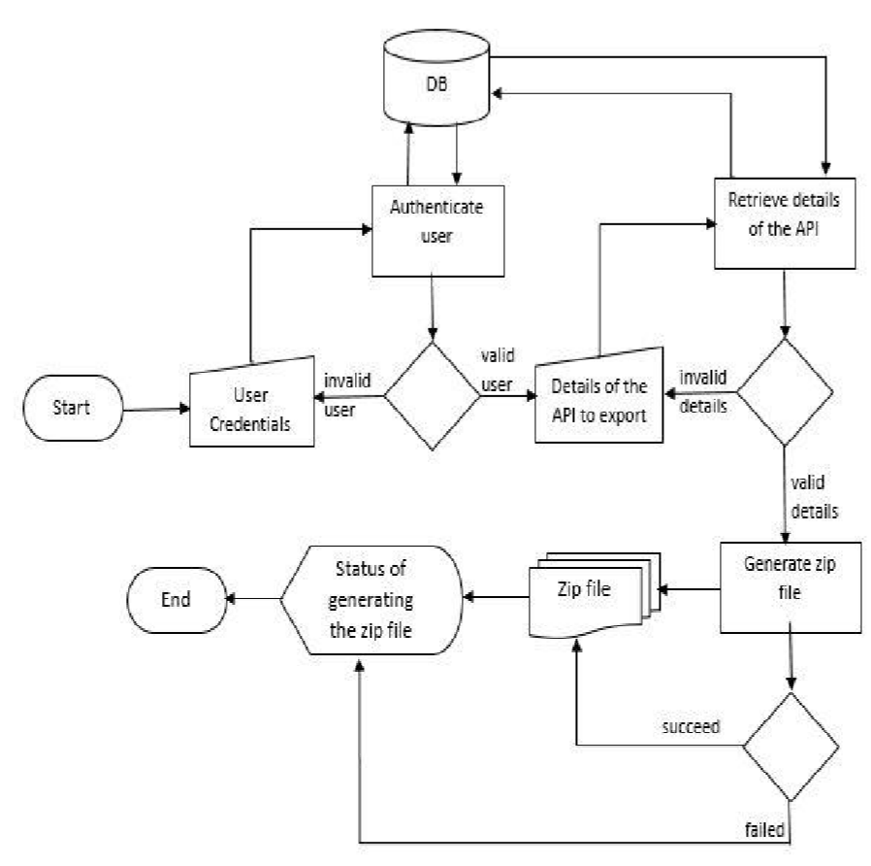

Figure 2.7 Flow of API Export Functionality

Upon exporting an API, all these resources should move to the new environment. These resources are residing inside data sources and at times in registries. Upon export, these components need to be retrieve from the original data source and copied into the exporting folder. As described in the section 3.1, these components can only be retrieved via REST API invocations.

API calls to resource endpoints will return the requested resources as attached to the response payload. This response can be in different formats as binary, json or xml etc. Those payloads are expected to convert into the required file formats and written in to a new folder. After all the resource files been written into the exporting folder, finalized folder will be compressed in to archive format. Overview of the process of resource retrieval is shown in diagram 2.8

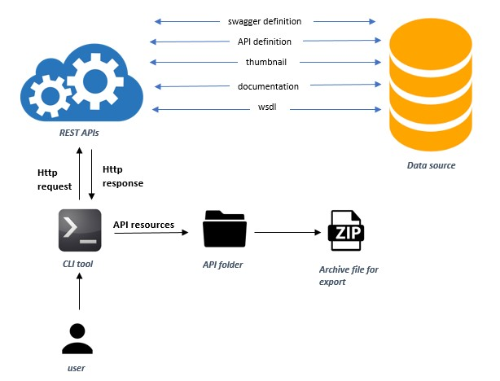

Figure 2.8 Overview of API export functionality of the CLI tool

After user sends the request all the information required for the requested API will be retrieve through REST API invocations from the data sources. After executing the relevant command, it will generate a portable zip file which includes all the entities bundled together and which can be downloaded. In the .zip file the Meta information which contains all the basic information required for an API to be imported in another environment and the API swagger definition, documents which contains the summary of all the documents available for the API, thumbnail image of the API, WSDL file of the API and the sequences available for the API will be available.

API export functionality retrieves the information required for the requested API from the registry and databases and generates a ZIP file, which the exporter can download. This exported ZIP file has the following structure shown in figure [2.9]

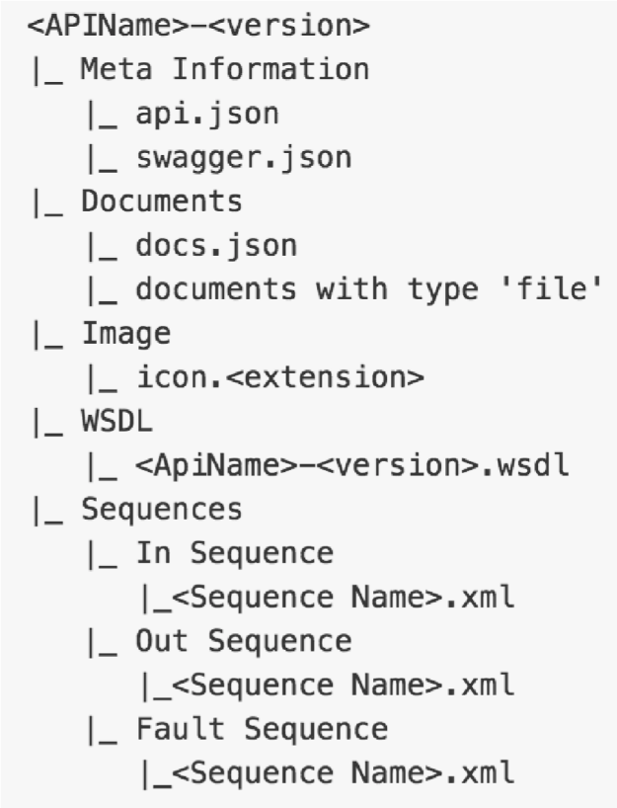

Figure 2.9 File structure of the portable API archive

Table [2.9] will explain the details of this entries in the archive folder created at the end of API export.

Table 2.1 Archive folder entries

|  |  |
| --- | --- |
| Meta Information | * Swagger.json : contain the API swagger definition * Api json: contain all the basic information required for an API to be imported to another environment. |
| Documents | * docs.json: contain the summary of all the documents available for the API. * Add the uploaded files for API documentation |
| Image | Thumbnail image of the API |
| WSDL | WSDL file of the API |
| Sequences | The Sequences available for the API |

### API import

API import is the process of recreating set of APIs that were in a different environment to a new environment. This includes all the activities starting from receiving imported API file to the new environment up to publishing the imported APIs in the publisher portal of destinations environment. None of the component should be dropped during the import process. APIs in the new environment should be exact to the original APIs in the previous development environment. Figure [2.10] shows the flow chart of the API import functionality.

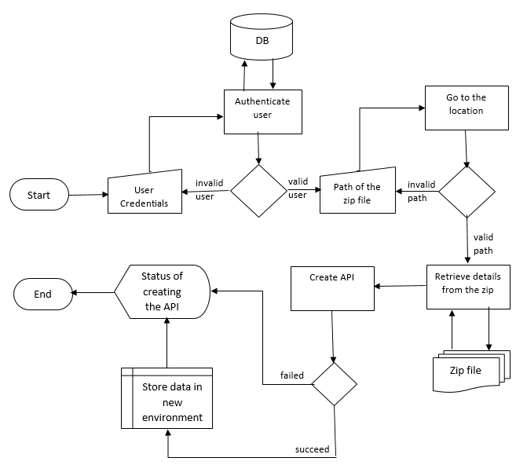

Figure 2.10 Flow chart of the API import functionality

Figure [2.11] shows how the interior data flow and API invocations takes place upon API import. Flow of the activities according to the order is as follows.

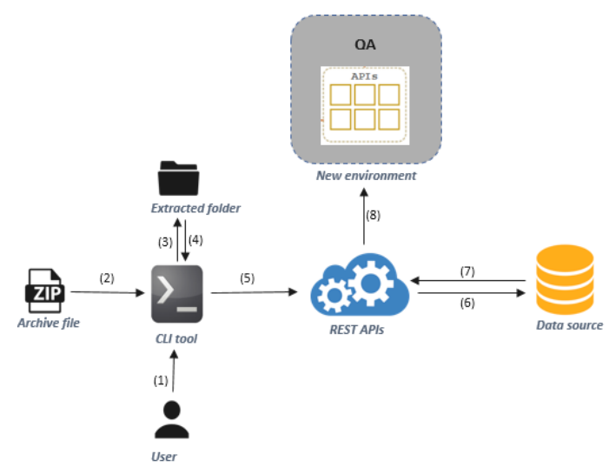

Figure 2.11 Workflow of the API import functionality

1. User execute the tool with valid user credentials. If valid, shows set of option through which use can select the option to perform API import.
2. User feed the file path to the imported archive file.
3. Tool itself extract the content inside the archive file in to a local temporary folder.
4. Tool will retrieve those content including API thumbnails, documentations, WSDLs, mediation policies.
5. Then it invokes the REST API endpoints with these components as the payload to save the API contents into the persistent data storage of the new environment
6. Data been saved in to the database.
7. REST API invocations retrieve the data related to each API from database
8. Create and publish the APIs in the publisher portal of the new environment.

API import functionality triggers when the tool been executed with the folder location to the imported compressed file. Along the execution tool prompt user for username and password to authenticate the user since only another API publisher can create the API in a new environment. After successful authentication CLI tool extract all the content in the compress folder and copied to a temporary local location. After that CLI tool will invoke the token generation endpoints to generate valid access tokens for the session.

REST APIs invoke with extracted content as payloads to create the API/APIs in the new environments and to upload the contents as thumbnails, WSDLs, mediation policies and documentations. As a result, exported APIs will be publish in the API store of the imported environment.

### API subscription

Subscription enables to generate access tokens and to be authenticated to invoke the APIs. Therefore, subscriber should subscribe to the API, before invoke it to an application since after subscribing to the API only, an access token can be generated to invoke the API to provide a valid authentication process. Therefore in this functionality proposed tool facilitate subscriber to add new subscription and also tool will provide the functionality to create a new application. Moreover, sub functionalities related to API subscription will also provide to the user by the CLI Tool. Figure [2.13] shows the flow chart of the API subscription functionality.

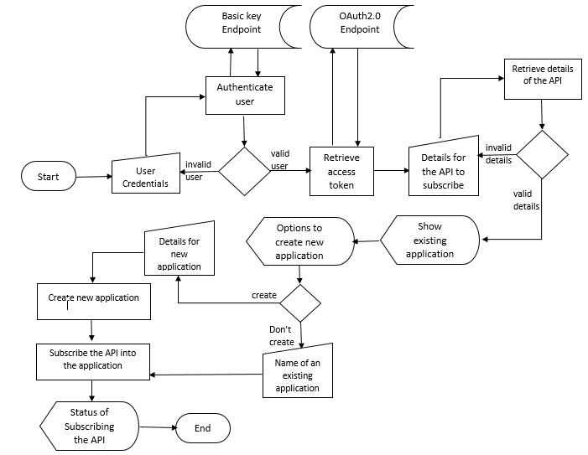

Figure 2.12 Flow chart of the API subscription functionality

Figure [2.13] shows the basic mechanism of the generate access token and add new API Subscription functionality. The component mainly divided into three processes; authenticate the user, generate access token and subscribe an API.

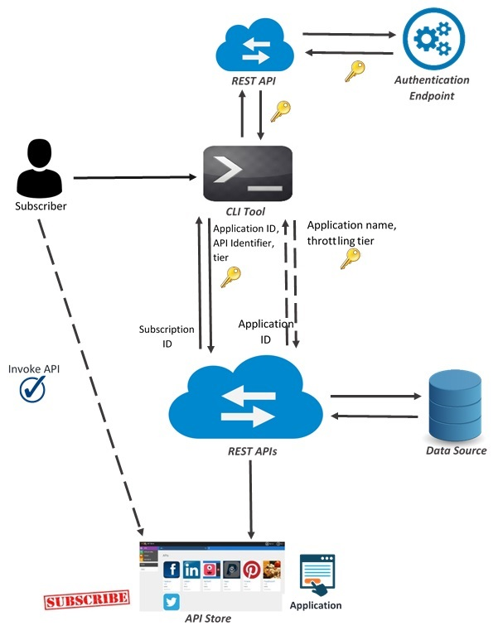

Figure 2.13 Overview of API subscription

To invoke an API into an application user has to subscribe the API to the application. To proceed into API subscription functionalities an access token is required in subscribe scope. After a valid user logged into the CLI Tool a client ID and client secrete can be retrieved by the basic authentication endpoint. The string should be encoded into Base64 string after preparing those two keys into a single string separated by a colon. When user select the option as API subscription, the encoded string will send to OAuth 2.0 authentication endpoint with the scope of subscribe. If the client credentials are valid it will generate an access token for subscription functionalities in scope of subscribe.

To subscribe an API first user has to provide the details of the API (API name, version, and provider) then the tool will arrange the API Identifier of the user selected API and send it to an endpoint which has the details of the APIs. If the selected API is a valid one, the tiers available for that API can be retrieved from the endpoint. Then the Tool will display the available tiers for the API.

User has to select a tier to continue. Then the tool will show the existing applications for that user. CLI Tool will provide the functionality of creating a new application as per the user’s requirement.

If the user required to create a new application, the CLI Tool will facilitate that functionality as well. To create a new application user only need to provide a name for the application and to select a tier for the application. Then it will be send through REST calls with the generated access token and will be created in the application. After selects an application the API will be subscribed into the selected application. The request is sent to the endpoint with the relevant API details, with generated access token with subscription scope. If the request successfully executes then subscription has been done in the API store. After that only user can invoke the API and use it in the application.

### Deploying APIs through kubernetes

Kubernetes is an open source orchestration system which provides for docker containers. There are some alternate docker orchestroms such as Docker Sworm and Mesus. Kubernetes, let to scheduled containers on a machine which make their cluster. Main task of container scheduler is to connect those containers on appropriate host after starting the first container.

It allows to run several containers on a machine and those machines make their cluster [30]. No matter whether they are long running services like web applications. Kubernetes services provides logical set of pods which can able to access them and called this as micro service too [18]. Kubernetes will manage the state of containers as follows,

* Let to start the container on a selected node

(Node is a worker machine in Kubernetes whether they are virtual machine or physical machine depending on the cluster. It is managed by the master components and have services to run pods). ▪ Restart the container when gets killed

(These containers are prepared to die at any time where can able to kill, stop and destroy them quickly).

* Let move containers from one node to another node.

**Why Kubernates to the CLI tool?**

The purpose of Kubernetes is to make it easier to organize and schedule your application across a fleet of machines. At a high level, it is an operating system for your cluster. Basically, it allows you to not worry about what specific machine in your datacenter each application runs on. Additionally, it provides generic primitives for health checking and replicating your application across these machines, as well as services for wiring your application into micro-services so that each layer in your application is decoupled from other layers so that you can scale/update/maintain them independently. While it is possible to do many of these things in application layer, such solutions tend to be one-off and brittle, it's much better to have separation of concerns, where an orchestration system worries about how to run your application, and you worry about the code that makes up your application

### Automation of migration with docker

Docker make easier to deploy CLI tool in several isolated environments. Always there may minor variation between development environments, unless have own repository environment. By using docker, fulfill that gap by keeping consistent environment because docker containers are configured to keep dependencies internally. Then it is easier to use same container and developer can ensure that they don’t need an identical production environment [31]- [32]. It means, no any restrict to run in amazon E2 instance and allow to use the same container in virtual box too. This will more important to use the CLI tool in different environment by using a same container.

Docker VM includes docker container where able to share the kernel and shared application libraries. It has layered file-system to share the OS in docker VM and hosted OS. Compared to VM, docker containers can be faster and less resources need to a single platform provide the shared OS [33]. Then After Add the docker file which have line between five to thirty lines to the machine. It is a small file but it is responsible for building docker image in docker VM. Then create the docker image using docker file to the project. Docker file contains several commands and instructions where execute in sequential order to build the docker image in docker virtual machine [34].

Docker image contains the all project codes and any installments of program regarding to build the project such as Golang and IntelliJ installations. This image is set on the top of machine and can able to create any number of docker containers and scale up those containers as we need. Then push the created docker image to docker hub and it includes whatever need to build the CLI tool. It is a cloud-based registry service and link to code repositories. Once receive the image to hub, build, test and stores pushed images which links to the docker cloud. Then it can be deployed in private hosts where provides centralized resources for team collaboration, Container image discovery, and work flow automation using development pipeline [35]. Docker hub provide following features,

* Add the hub and docker image to own workflows where GitHub or Bitbucket integration
* Provides to create work group to access the repository which includes docker image
* Docker image will renew automatically after make change the code of the CLI tool.
* Pull images from docker hub and manage, push to, and pull to the own repository which is accessed by us.

Now any other users can run the CLI tool without need any installation of their computers. It means, no need to install Golang or intellij idea and work it as a VM. Overall architecture of docker where involve to the project as shown in Figure 2.14

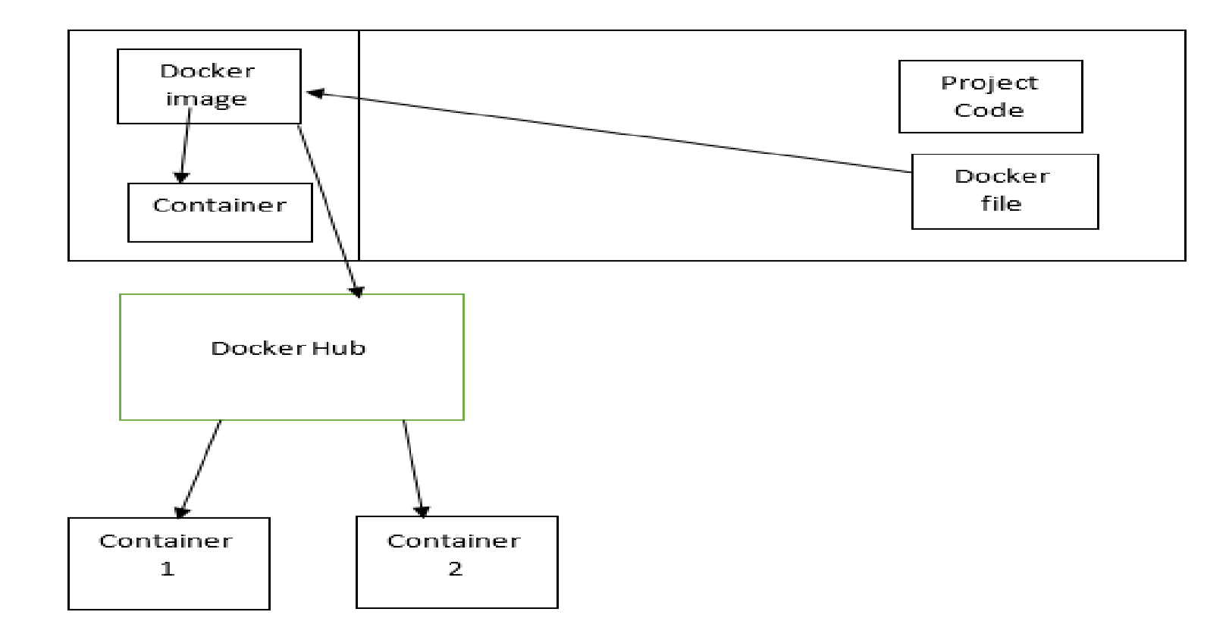

Figure 2.14 Code flow of docker in CLI tool

When push and commit the project in to the docker hub time to time, Jenkins grab the latest code as soon as possible. If any build error occurred in the project, trigger immediately to the Jenkins and reverse the commit before last without finding the error in the code. Once the build is successful, project is tested on several tests such as integration test, unit test and the performance test automatically and send back it as report. If exceptions occurred while testing, can easily troubleshoot issue. However, this is the continuous integration involve with project.

To monitoring the basic services such as containers, nodes and topology, need to install Cockpit to PC. It is a free open source system monitory application and check work perfectly.

It can monitor the services using one of both web interface and command line. But we expect to use the web interface which provide more easy access and manage. If any services error occurred, we can find easily. Work flow of the docker in CLI tool is shown in figure 2.15. Then after install kubernetes and kubernetes API server which is managing related distributed the docker containers.

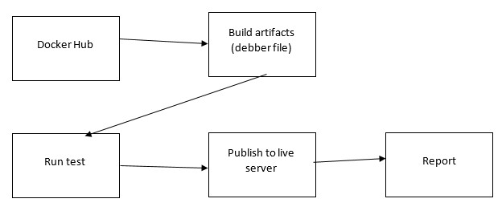

Figure 2.15 Work flow of the docker in CLI tool

## Research Findings

Objective of the research project was to come up with platform independent, efficient and powerful CLI tool to perform API migration across different environments. There were several API managing applications available in the market and few out of those have defined certain methodologies to perform API migration as well. Features like platform independency, API subscription are still foreign for them. Therefore, development had to be start from the beginning.

During the literature survey, we found that most of the currently existing tools doesn’t have strong security mechanism to ensure the copy write of proprietary API resources. Taking this in to consideration we have implement the built-in security mechanism in the tool itself using Basic auth and OAuth 2.0 as technologies.

We found out most of the commercially available migration tools can’t perform multiple API import and export at a single time (Doesn’t support bulk import and export). We could find techniques to perform bulk API import/ export at a single instance and reach efficiency-wise and performance-wise achievement to the first time in the market.

Although there’s a big demand in the market for a CLI tool that will automate the application creation and subscription in the market none of existing tool could come up with solution that fulfil user requirement. In our CLI tool that was implemented to provide service for API migration, we could extend the intended functionality and provide that functionality. This will be an added advantage on marketing out product among existing tools in the current market.

Platform dependency was another disadvantage in existing tools such that their implementations were heavily depend on the implementation of the API managing application it built for. This limitation was break in our migration tool by introducing a simple configuration file that will hold the platform specific properties. With few modifications to this configuration file user can use the same tool for any other REST based API managing applications.

Could computing is the emerging technology that is drawn in to the API management. Talking this in to consideration and based on a quick market analysis, we implemented and performed a single cluster deployment via minikube and we deployed the product in google cloud as well.

WSO2 APIM was used as the interface for the research domain and furthermore we escalate the deployments in Google container engine deployment and also the minikube deployment and we find out the zero-down time of the API can be achieved with use of the rolling update concept in kubernetes and also to reduce the traffic in to the container we used replicas concept in kubernetes. As per tricks for the developers who are doing the deployments there’s a huge bug in the MySQL docker base image in itself when deploying in the GKE it’s searching for lost+found in the container in order to find the root folder to initialize the data and it’s a must add an argument to reduce the impact that happened from this. Also, when it comes to persistent volumes it’s a must to add false for kubernetes inbuilt volume initialization. Otherwise it will not go with the yaml implementation on initialization of the volumes.

# RESULTS AND DISCUSSION

Final product of our research project on implementing ‘Efficient and Platform Independent CLI Tool for API Migration is a executable jar file which can be execute via the command line interface on top of any platform. This is a single tool with multi-functionalities including,

* Single/multiple API import
* Single/ multiple API export
* Application creation
* API subscription
* Single cluster deployment via minikube
* Google cloud deployment

Key benefits through the application includes the following:

* Platform independency
* Higher efficiency though optimal resource utilization
* Enhance security functionalities along migration
* More automated features
* Plug and play solution

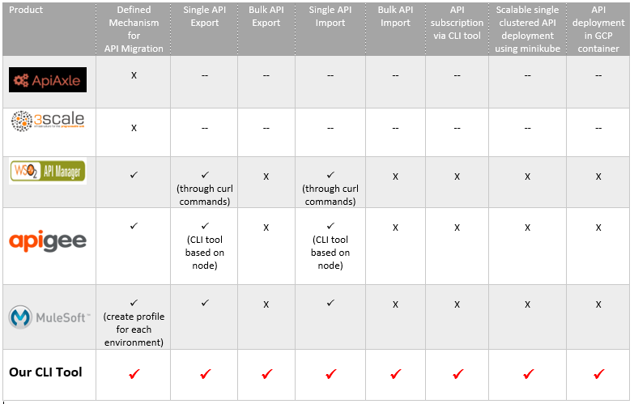Figure [3.1] shows a lower level comparison between our product and API migration mechanism of few API managing vendors

Figure 3.1 Functional comparison between our CLI tool for API migration and few trending migration tools in current industry

## Evidence

### Authentication mechanism and access token generation

First user have to enter the username and password. Figure [3.2]

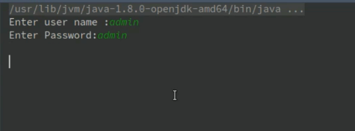

Figure 3.2 System login

User credentials will be encoded into Base64 string and pass into basic token endpoint. Then the client ID and client secrete can be retrieved from the endpoint and send the Base64 encoded key (client ID: client secret) into OAuth 2.0 authentication endpoint. It will validate the credential and generate an access token according to the given scope. After that using that access token only the tool can proceed to further functions. Figure [3.3]

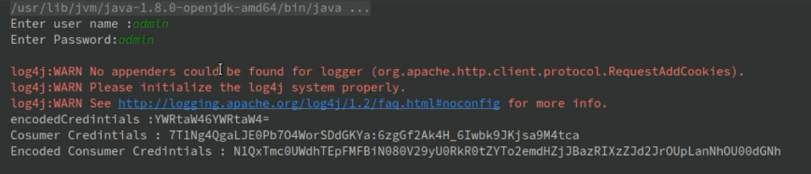

Figure 3.3: Encoded User Credentials

Then the tool will show user the main functionalities which can be done through the CLI tool. Figure [3.4]

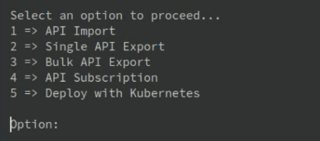

Figure 3.4: Main functionalities

### API export

Following are command line interfaces related to exporting of APIs from API manager. Initially user must execute the tool with valid user credentials. Figure [3.5]

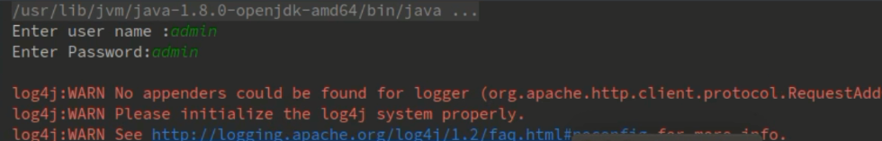

Figure 3.5 Interface of Basic authentication

If the user is authenticated, tool will show a list of option which user can proceed with. Figure [3.6] show the available list of operations. Select option 3 to observe the bulk export.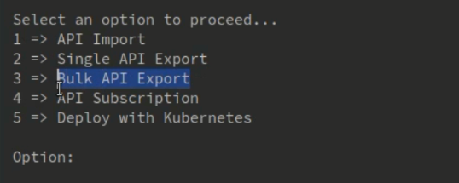

Figure 3.6 Select options to proceed

A csv file should be created including the API identifiers of the list APIs need to export as a bundle. Tool prompts for the path to csv file containing the list of APIs to be export. Figure [3.7]

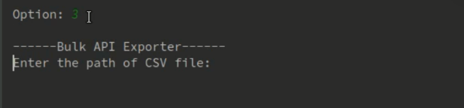

Figure 3.7 provide the path of CSV file

Figure [3.8] shows the list of API identifiers in the csv file.

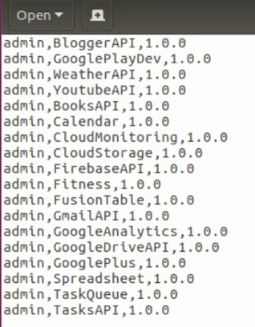

Figure 3.8 All API Identifiers

Then the tool will retrieve all the content of the APIs in to a transportable archive file. Separate folder will create for each API. Figure [3.9]

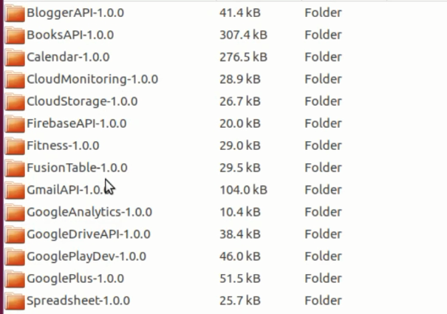

Figure 3.9 Created archive folder

### API import

Before the API been import, API publisher portal of the new environment just has only API which is created by the owner of that environment. Figure [3.10]

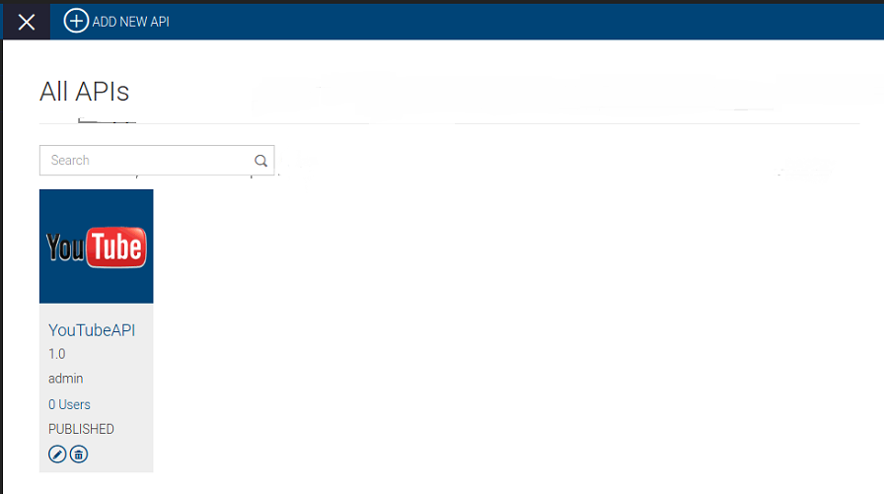

Figure 3.10 Original imported environment

From the list of options displays at the tool execution select option 1 to proceed with API import. Figure [3.11]

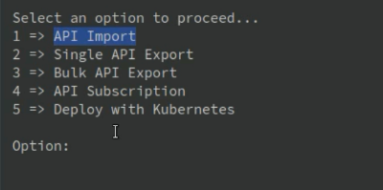

Figure 3.11 Option list by the CLI tool

Then the tool prompt for the file path of the imported archive folder.

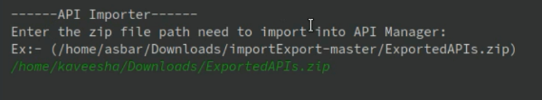

Figure 3.12 File path to the archive folder

Entering the file path will trigger the API import and create and publish all the APIs contained in the imported folder. Figure [3.13]

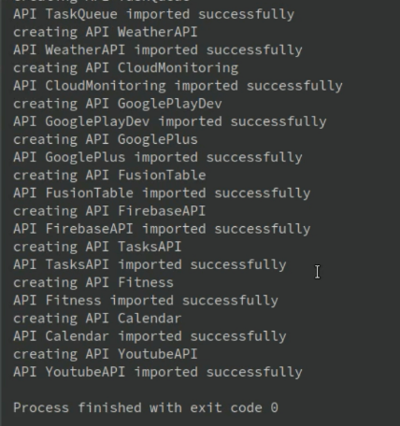

Figure 3.13 Successfully imported APIs

After API import, all the APIs are created in the new environment. Then publisher portal of the destination environment look as follows as in the figure [3.14]. Owner of this environment can publish and expose these API in to the stakeholders by manually publishing those from the developer portal.

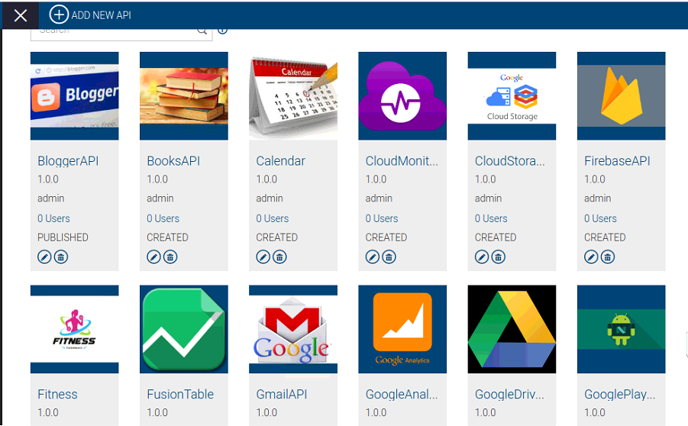

Figure 3.14 Destination environment after bulk API import

### API subscription

After the validating process of the user tool will show the available functionalities. To process into API Subscription functionalities user first have to select number 4 as the option. Figure [3.15]

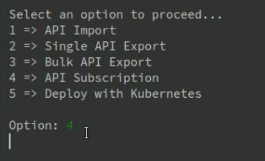

Figure 3.15: Main functionalities

To add a new API subscription user only have to enter no. 1 as option. Figure [3.16]

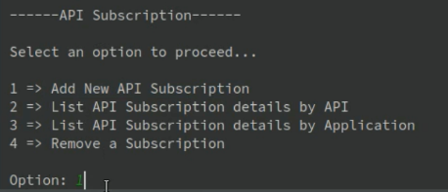

Figure 3.16: Sub functionalities of API Subscription

Then retrieve an access token for subscription scope. Figure [3.17]

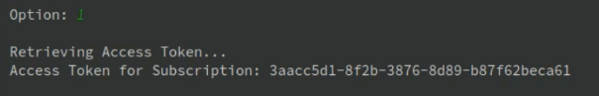

Figure 3.17: Example generated access token for subscribe scope

Then have to enter the API details and select the tier for the subscription.

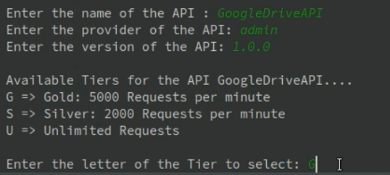

Figure 3.18: Details required when adding a new subscription

Tool will display existing applications. As per the requirement of the user, the tool will provide functionality of creating an application if required. Therefore, user can either select an existing application or can create new application to add the subscription.

If required to create a new application user have to enter ‘y’ as the option enter a name and select a tier for the application which controls the number of request per minute.

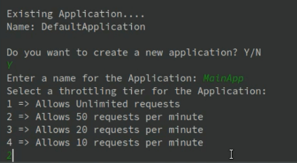

Figure 3.19: Creating a new application

After that the subscription will happened successfully to the application. Therefore, now the invocation of the API has authenticated by the subscription. Now only user can invoke the API in the application.

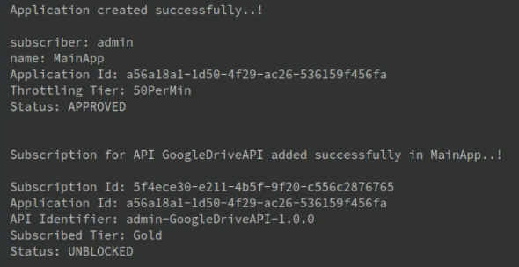

Figure 3.20: Interface of after successfully adding a subscription

The newly created application and the added Subscription will be available in the API Store.

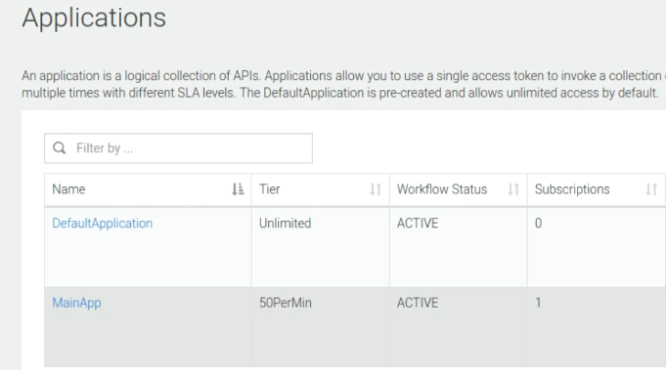

Figure 3.21: Applications available in API store

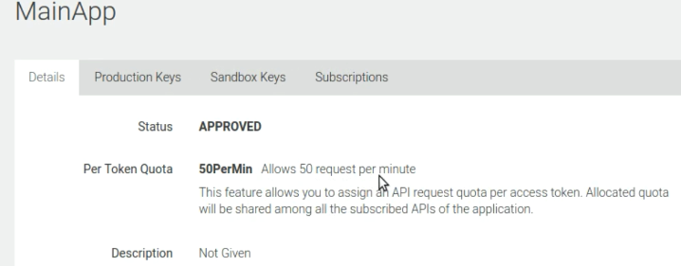

Figure 3.22: Details of the created application

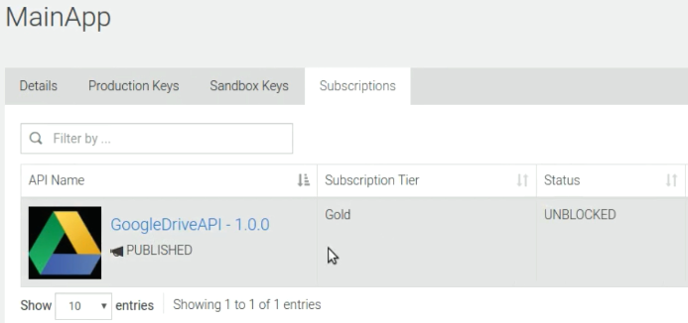

Figure 3.23: Subscriptions for the application

User has to select the option as number 2 then need to add the details of the API. After that tool will show the subscription details for the API.

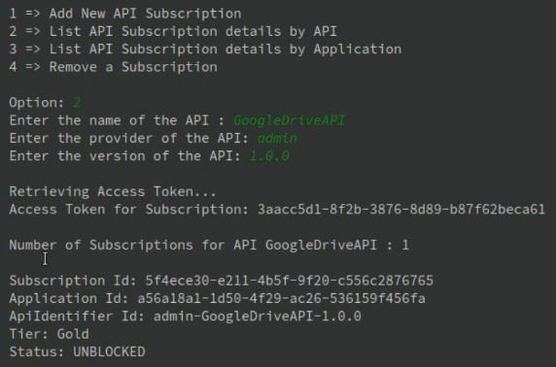

Figure 3.24 List subscription details by API

User has to select the option as number 3 then need to add the details of the API. After that tool will show the subscription details for the application.

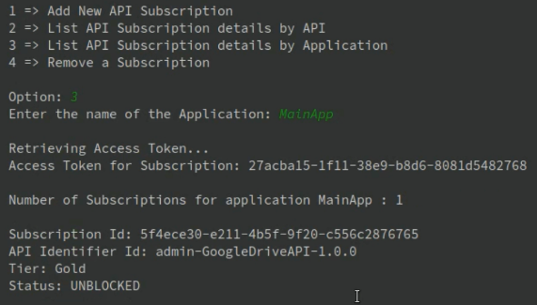

Figure 3.25 Subscription details by an application

User has to select the option as number 4 then tool will show the available applications for the user. User has to enter the name off the application to unsubscribe an API.

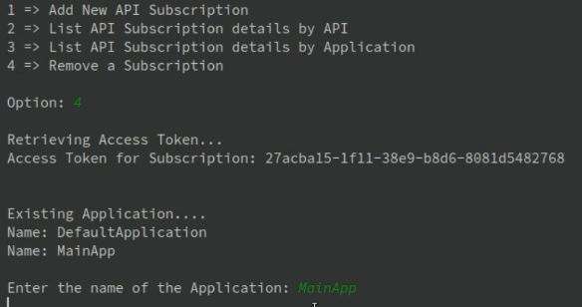

Figure 3.26 Selecting an application to unsubscribe an API

Then it will show the subscribed APIs in the selected application.

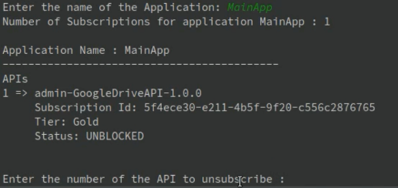

Figure 3.27 List of APIs subscribed by application

User need to enter related number for the API to unsubscribe from the application. After that the API will be unsubscribe from the application.

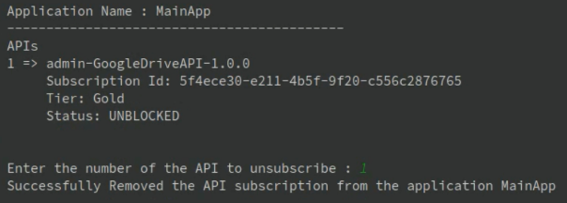

Figure 3.28 Selecting an API to unsubscribe.

### Single cluster deployment in minikube.

Minikube cluster deployment of the created docker image for testing. And as it shows it get deployed and the endpoint is accessible through a curl command and Scaling the deployment to handle the traffic in to the container is handled in the CLI tool.

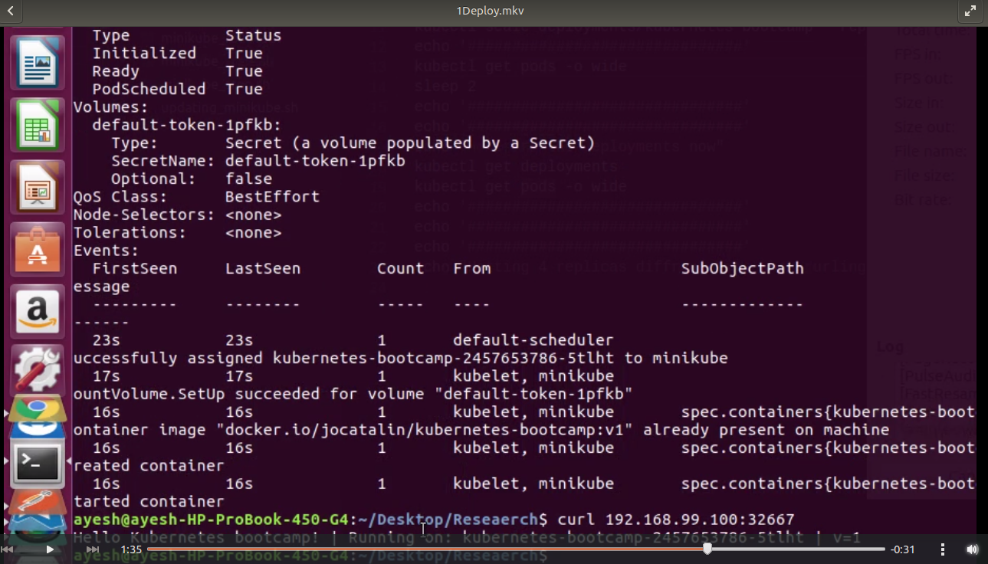

Figure 3.29 Minikube Cluster Deployment

Figure XX shows that the master node will send the request from the outside to its slave replicas to reduce the traffic. This is a main concern in software development industry. As per the image when we curl in to the endpoint it returns the results from various pods.

Rolling update will manage the zero-down time. When it comes to API management sometimes the testing goes for days within the time to maintain an update to the API will not be added in the current industry practices but still with the deployment we can handle that task from the cli tool. First, it’s first image secondly now it’s v2 image

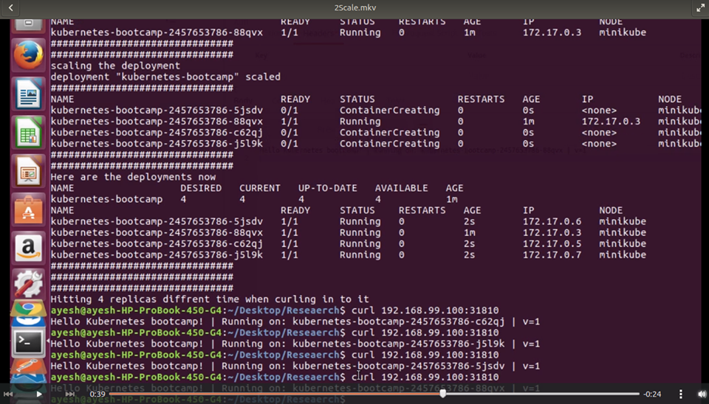

Figure 3.30 Minikube Scaled Deployment

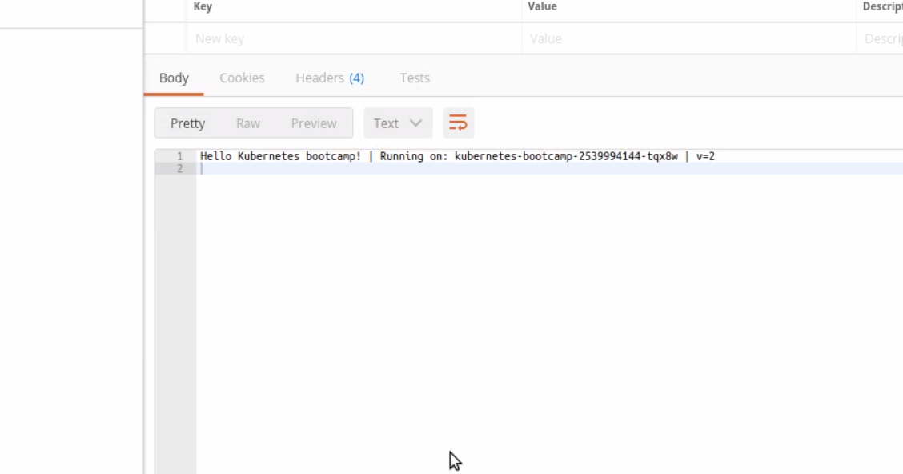

Figure 3.31 Showing the before rolling update get request

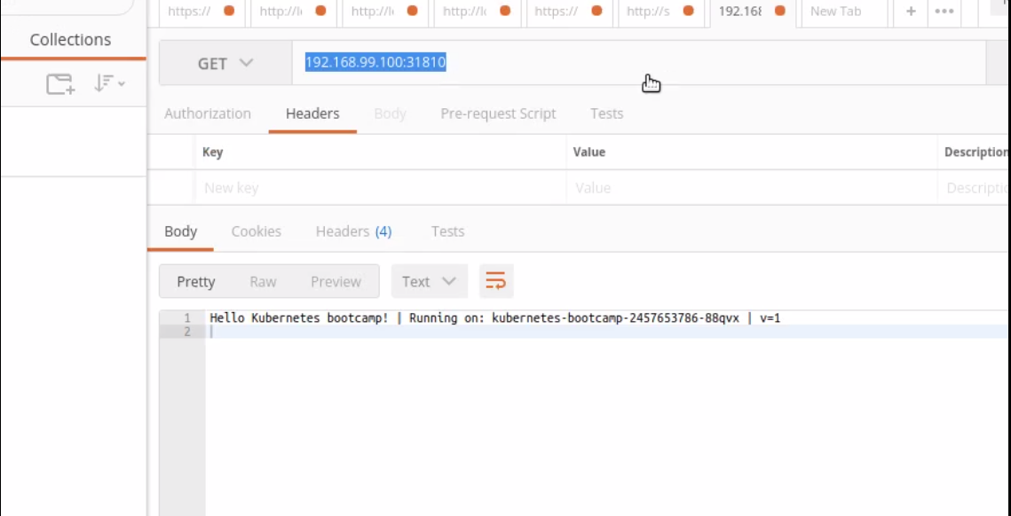

Figure 3.32 After the update get request

### Google container engine cluster deployment.

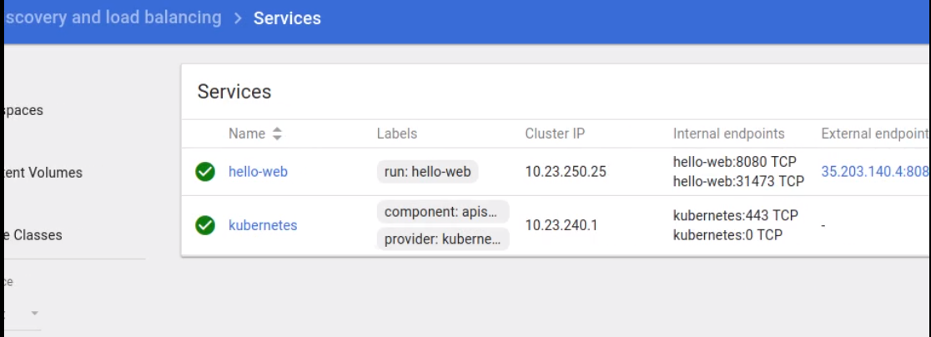

Figure 3.33 Google Container Engine Deployment

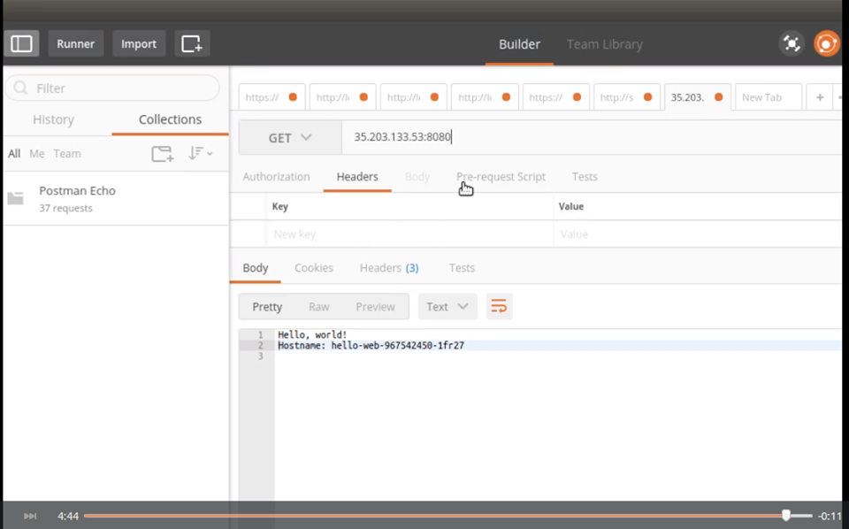

Figure 3.34 Get request to the container

## Discussion

Nowadays, APIs are important to a developing organization since APIs will help to improve the efficiency, automation, personalization aspects of services expose by the organization [36] [37] [38] [39] [40]. When there’s a requirement to move the created APIs in one environment into another environment, users must recreate those in the new environment manually. Time, resources and cost are wastage is common because of the redundant processes. There are only few tools that support for API migration and those tools still haven’t address drawbacks as;

* Individual components should be deployed separately. Required to create the component one by one and lot of redundant processes will be occurred. Therefore, lot of time, developer effort and resources will be wasted.
* Limited developer portal functionalities will cause to reduce the performance.
* Unnecessary amount of resources will be wasted and network traffic will be occurred because of the wastage of bandwidth.
* No built-in support for strong authentication. Since lot of mechanisms relies on 3rd party authentication applications and it requires always to connect with the 3rd party applications will help intruders to access the private information easily.
* The lack of functionality. Ex. most of the CLI tools does not support API Subscription.

If anyone can address above drawbacks, it can increase the accuracy rate, performance and security of the migration process. Our tool was primarily developed targeting above mentioned problems and introduced new functionalities targeting the fore coming marketing trends. Following are such specific features expose by our CLI tool for API migration.

* The tool is a generic tool where many APIM application by different vendors can be used for their APIM applications.
* Tool can execute on different platforms such as windows, linux to achieve platform independency.
* Introduced a strong authentication mechanism using Basic auth and OAuth 2.0 authentication mechanisms to provide a better authentication throughout the functionalities of the CLI Tool.
* Proposed tool contains new functionalities such as API subscription which most of the CLI tools does not contain.
* Moreover, reduced user’s manual steps through the tool by Enhancing automate feature and do not required any additional configurations to use the tool.

As a result, lot of time, resources, developer effort and cost can be saved while having a better performance, accuracy rate and an efficiency level by using this CLI tool.

Even though API migration tool is very easy to use everyone, we hope to provide complete documentation and guidelines on usage of the system. It ensures the relevant users to the access the accessibility tools of operating system, without affecting the API migration tool’s functionality. Furthermore, it includes instructions in simple languages with screenshots and provide accessible support materials, training and documentations.

### System performance

Generally, creating an API with minimalistic features, without any WSDLs, median policies, and documentations cost u approximately 2minutes and 30 seconds in any typical API managing product. If a user need to create 20 of such APIs in a new environment it takes around 90 minutes to create the whole set of APIs. API import is the process where we rebuild the API using the received API resources in a new environment. Performance our API migration tool is commendable such that it can create whole set of this 20 APIs within less than 1minute and 40 seconds. Following calculations explain about the performance gain can acquire through this tool.

Average time taken to create a simple API = 150s

Average time taken to create 20 simple APIs = 150s * 20

=3000s

Approx. time taken by tool to create 20 APIs = 100s

Performance gain = ((3000s – 100s)/ 3000s) * 100%

= 96.66%

### System interfaces

CLI tool works for the API manager applications built on top of the REST APIs. All the resources related to an API resides inside database and those cannot be access directly via the CLI tool. API manager applications has defined REST APIs to retrieve those resources from the database. Further, uploading and updating the data inside the databases also cannot be done directly from external tool. There are defined REST APIs to perform those. The CLI tool implementing will use these available REST APIs to retrieve and restore the data from and to the database.

### User interfaces

User interfaces act as the logical interface between users and the system. Since this is a Command line interface tool, interfaces may not be including any UI components as layouts, buttons, icons an image. Instead it will be textual commands that display on the command line interface and accept user inputs via the prompts. Still tool will interact with the users via ordinary command prompts when necessary. Therefore, the complexity of the user interfaces is very low and any type of regular users can understand the interface very easily.

Any error messages and recovery options will be display as plain text in the command line interface and will act user friendly as much as possible through a command line interface.

### Hardware interfaces

Physical: 3GHz Dual-core Xeon/Opteron (or latest), 4 GB RAM (minimum: 2 GB for JVM and 2GB for the OS, 10GB free disk space (minimum) disk based on the expected storage requirements (calculate by considering the file uploads and the backup policies) .

### Software interfaces

This is platform independent CLI tool. And it’s a generic solution which can be plug and play with any APIM tool. OAuth 2 will be used for authentication purposes. And Golang will be used as the backend language RESTful web services will invoke the endpoints. Docker containers will be used to handle export API’s and also Git hub and Jenkins will be used as repository and the continuous integration tool. Furthermore, to deploy an API and to monitor it will be used kubernetes platform

### Communication interfaces

* 1. HTTP protocol
  2. Access to internet is needed through the whole process
  3. REST APIs

### Memory constraints

The application is expected to use no more than 2GB RAM to smoothly run the application and 500MB of external storage to store the created API’s and its resources that are retained from backend.

### Site adaptation requirements

CLI tool implementing is a generalize tool that is capable of use by several API management products. Tool maintains a separate configuration with default configurations. From a one API managing product to another this configuration file need to be change if necessary, in order to meet the optimal functionality out of the tool. This configuration file may include the data including token endpoints, REST API URLs and any default file names and folder locations.

System should be connected to the API store of the API managing product over the internet to retrieve the details regards to the API been import or export.

To support the process of automated deployment executing machine should install and configure docker and kubernetes beforehand.

Command line must include separate help functions to help users to identify the commands for various tasks to perform. User must be notified properly within the time he entered a command through the CLI tool and proper instructions will be given to the user. Further, proper progress indications should be updated to the client to maintain the responsiveness of the application.

### Constraints

**Issue in Supportability testing**

This CLI tool is to be developed as a generic tool which support for multiple API managers to migrate the APIs. Anyway, wso2 API manager is the only open source API manager available and want to purchase other API Managers for use. At the completion of the project, need to follow some several testing criteria including compatibility testing. By the way, it is very expensive and highly cost for purchasing those API managers to do the compatibility testing.

**Draw backs in Docker**

When it comes to composing a complex application stack by using Docker still it will be a challenge. As Dev. OPS developer often have to

1. Connect to a preexisting server
2. Have to bind environmental variables to avoid hard coding values. Especially when the application contains and requires thousands of dependencies

**Phishing**

OAuth is safe there’s no doubt about the safeness of the third-party Authentication provider. But asking for login in to different site can quickly change the user to be careless and less educated users will think that it’s a safe approach and will unfortunately fall in to victim of their data phished

### Assumptions and dependencies

1. Expected stable internet connection when working with the tool.
2. Required minimum 2GB Memory and minimum 512 MB heap size.
3. Required approximate minimum disk size of 500 MB for a fresh installation pack, excluding space allocated for log files.
4. Required to installed jdk 1.7 or above, since the tool will be developed using on top of jdk, which is platform independent.
5. Enabling JavaScript in the web browser may give the full advantage of the tool.
6. Platform dependencies does not affect for the tool since the tool will be developed using java to be a generic product [41].

# CONCLUSION

API migration is becoming an essential functionality need support by API managing products which will allow developers to migrate the created APIs from one development environment to another as well for the API publishers to exchange their created APIs with other API publishers. Current mechanisms provided by several API management products have identified problems like delegation of key security functionalities to third parties, individual components need to be deploying separately, limited developer portal functionalities, and limited automated features, which are not addressed yet. Therefore, a requirement for a powerful, platform independent and efficient tooling supporting for this domain is still at a growing stage. In our research project we presented CLI tool which could overcome those identified issues in current existing tools and having capability to address the performance issues currently undergoing. Main functionalities expose by out migration tool can be split in to four as API export, API import, API subscription and application deployment

To perform all these activities, tool should be executed by a valid user. Access to tool is verified and validated by two key security mechanisms. Basic level authentication is done through the Basic Authentication technology and REST API invocations are secured by the access tokens generated via OAuth 2.0.

API export functionality allow the user to retrieve all the components related to API/APIs as API definition, swagger definition, thumbnails, mediation policies and bundle them up to a single transportable archive file which can be transfer to any environment. User just have to execute the tool with API identifiers or the required APIs.

During the API import users has to trigger the CLI tool with the local folder path to the imported archive file. Users do not have to deploy each component separately. Once the tool is triggered, it will extract all the content of the imported folder to a temporary local folder. Tool then retrieve those content to create and publish the imported APIs in the new environment by invoking the available REST APIs.

None of the existing migration tools have introduce the functionality to perform API subscription. API subscription allows the user to create applications with required tier levels and subscribe to any API identified by the API identification via that application or any other applications available in the API store. Entire process is handle via the CLI tool. This makes developer portal functions fast and easy.

Using two virtual or physical machine on creating the kubernetes cluster will help on maintain the traffic and update the product with a zero downtime and efficient replica allocation other than using a minikube cluster with a one worker node.

All these functionalities collectively will address most of the drawbacks that haven’t been address in current API migration tools. This tool will facilitate the developer effort in developing API manager applications and enhance the developer productivity by eliminating unnecessary time and effort wastage arise during API migration across different environments.

# References

|  |  |
| --- | --- |
| [1] | WSO2, "Managing a multi-environment deployment," WSO2, [Online]. Available: http://wso2.com/library/articles/2016/03/article-architecting-a-multienvironment-API-manager-deployment-with-wso2-API-manager/. [Accessed 20 02 2017]. |
| [2] | M. Rouse, "API Management," 05 2016. [Online]. Available: http://searchmicroservices.techtarget.com/definition/API-management. [Accessed 25 02 2017]. |
| [3] | A. Balaganski, "API Security Management," in *LEADERSHIP COMPASS* , 2015, pp. 20-27. |
| [4] | K. Wahner, "Open API and API Management - Introduction and Comparison of Products: TIBCO API Exchange, IBM, Apigee, 3scale, WSO2, MuleSoft, Mashery, Layer 7, Vordel," Confluent, 22 10 2014. [Online]. Available: https://www.slideshare.net/KaiWaehner/a-new-front-for-soa-open-api-and-api-management-as-game-changer. [Accessed 24 03 2017]. |
| [5] | A. ANTHONY, "Nordic APIs," 16 04 2016. [Online]. Available: http://nordicapis.com/tracking-the-growth-of-the-api-economy/. [Accessed 28 04 2017]. |
| [6] | S. Wray, "APIs increase profits, new research shows," 9 11 2016. [Online]. Available: https://inform.tmforum.org/nfv-it-transformation/2016/11/apis-increase-profitsresearch-shows/. [Accessed 14 03 201]. |
| [7] | C. Burton, "The Five Axioms of the API Economy: The Macro Effects of APIs – Rise of the API Economy," 19 11 2014. [Online]. Available: http://www.craigburton.com . [Accessed 14 03 2017]. |
| [8] | M. O. Paolo Malinverno, "Magic Quadrant for Full Life Cycle API Management," 27 10 2016. [Online]. Available: https://www.gartner.com/doc/reprints?id=1-3J3G4AE&ct=161003&st=sb. [Accessed 27 02 2017]. |
| [9] | M. serves, "Forrestor," 07 06 2015. [Online]. Available: http://blogs.forrester.com/michael_yamnitsky/15-06-07- the_api_management_solutions_market_will_quadruple_by_2020_as_business_g oes_digital. [Accessed 25 04 2017]. |
| [10] | S. Sharma, "Ovum Decision Matrix: Selecting an API Management Solution," Ovum, 2016-2017. |
| [11] | S. Sharma, "Ovum Decision Matrix: Selecting an API Management Solution," 04 2016. [Online]. Available: https://www.ca.com/content/dam/ca/us/files/industry-analyst-report/ovumdecision-matrix-selecting-an-api-management-solution-2016-2017.pdf.11. [Accessed 17 03 2017]. |
| [12] | G. P., "APIgee_environment_Migration tool," 07 2016. [Online]. Available: https://www.npmjs.com/package/APIgee_environment_migrationtool. [Accessed 27 02 2017]. |
| [13] | MuleSoft.com, "Deploying to Multiple Environments," MuleSoft.com, [Online]. Available: https://docs.mulesoft.com/mule-user-guide/v/3.6/deploying-to-multipleenvironments. [Accessed 27 02 2017]. |
| [14] | "Secret of great API," MuleSoft, [Online]. Available: https://www.mulesoft.com/ty/wp/secrets-great-api. [Accessed 24 03 2017]. |
| [15] | D. Stevenovic, "WSO2TORIAL: Migrating the APIs to a Different Environment," WSO2, 11 09 2015. [Online]. Available: https://www.yenlo.com/blog/wso2torial-migrating-theAPIs-to-a-different-environment. [Accessed 28 02 2017]. |
| [16] | AWS, "AWS CLI Command Reference," AWS, [Online]. Available: http://docs.aws.amazon.com/cli/latest/reference/ . [Accessed 15 03 2017]. |
| [17] | fliaa01, "CA API Gateway 8.3.00 released," CA, 17 03 2015. [Online]. Available: https://communities.ca.com/thread/241725934. [Accessed 15 03 2017]. |
| [18] | MuleSoft, "The Top Six Microservice Patterns," MuleSoft. [Online]. |
| [19] | A. R. Earls, "Old SOA versus new SOA? Open APIs change the game," 03 2012. [Online]. Available: http://searchmicroservices.techtarget.com/feature/Old-SOA-versusnew-SOA-Open-APIschange-the-game. [Accessed 15 03 2017]. |
| [20] | D. Burg, "Using Google OAuth 2.0 authorization server in Azure API Management," 2017, 25 07. [Online]. Available: https://support.3scale.net/docs/api-authentication/oauth2. [Accessed 02 10 2017]. |
| [21] | Azure, "Code flow of the OAuth 2 specification," Azure, 21 09 2014. [Online]. Available: https://dzimchuk.azureedge.net/blog-content/OAuth2-Authorization-Code-Grantupdated2.png . [Accessed 18 03 2017]. |
| [22] | M. Hamann, "Migrate your Connect & Compose APIs to API Connect," 26 07 2016. [Online]. Available: https://www.ibm.com/blogs/bluemix/2016/07/migrate-connect-compose-apis-apiconnect/. [Accessed 10 04 2017]. |
| [23] | I. K. Center, "Working with Products in the API Manager," IBM, 07 04 2017. [Online]. Available: https://www.ibm.com/support/knowledgecenter/en/SSMNED_5.0.0/com.ibm.apic.apionprem.doc/task_product_management.html. [Accessed 23 04 2017]. |
| [24] | WSO2, "API Management Platform Technical Evaluation Framework," WSO2, 2016. [Online]. Available: http://wso2.com/wso2_resources/wso2_whitepaper_api-management-platformtechnical-evaluation-framework.pdf/ . [Accessed 24 03 2017]. |
| [25] | L. B. M. T. O. Trevor Perrin, "Delegated Cryptography, Online Trusted Third Parties, and PKI," in *1st Annual PKI Research Workshop*, 2002. |
| [26] | M. Libraries, "What are scholarly resource APIs ?," MIT, [Online]. Available: http://libguides.mit.edu/apis. [Accessed 14 03 2017]. |
| [27] | WSO2, "Building an Ecosystem for API Security," WSO2, [Online]. Available: http://wso2.com/wso2_resources/wso2-whitepaper-building-an-ecosystem-forapi-security.pdf/. [Accessed 17 03 2017]. |
| [28] | AWS, "OAuth2 Role’s to be identified," AWS, 2015. [Online]. Available: https://s3.amazonaws.com/dfcwiki/en/images/6/6f. [Accessed 18 03 2017]. |
| [29] | WSO2, "Authorization code grant type with WSO2 API manager," WSO2, [Online]. Available: https://docs.wso2.com/download/attachments/29922435. [Accessed 18 03 2017]. |
| [30] | Google, "Large-scale cluster management at Google," Google, [Online]. Available: https://research.google.com/pubs/pub43438.html. [Accessed 26 03 2017]. |
| [31] | T. Vase, "ADVANTAGES OF DOCKER," University of Jyväskylä, 2015. [Online]. Available: https://jyx.jyu.fi/dspace/bitstream/handle/123456789/48029/URN%3ANBN%3Afi%3Ajyu-201512093942.pdf?sequence=1. [Accessed 25 05 2017]. |
| [32] | N. D. Loof, "Docker Hub 2.0 Integration with the CloudBees Jenkins Platform," 21 09 2015. [Online]. Available: https://dzone.com/articles/docker-hub-20integration-with-the-cloudbees-jenki. [Accessed 17 04 2017]. |
| [33] | S. Sheshachala, "Docker vs VMs," 24 11 2014. [Online]. Available: ://devops.com/docker-vsvms. [Accessed 15 03 2017]. |
| [34] | M. Arul, "How to create Docker Images with a Dockerfile," [Online]. Available: https://www.howtoforge.com/tutorial/how-to-createdocker-images-with-dockerfile/ . [Accessed 17 03 2017]. |
| [35] | D. Doc, "Overview of Docker Hub," Docker, [Online]. Available: https://docs.docker.com/docker-hub/. [Accessed 17 03 2017]. |
| [36] | A. B. Steve Danielson, "How to import the definition of an API with operations in Azure API Management," 23 01 2017. [Online]. Available: https://docs.microsoft.com/enus/azure/api-management/api-management-howto-import-api. [Accessed 11 04 2017]. |
| [37] | M. Rouse, "API economy (application programming interface economy)," [Online]. Available: http://searchmicroservices.techtarget.com/definition/API-economyapplicationprogramming-interface-economy . [Accessed 14 03 2017]. |
| [38] | M. S. Bala Iyer, "The Strategic Value of APIs," 07 01 2015. [Online]. Available: https://hbr.org/2015/01/the-strategic-value-of-apis. [Accessed 17 03 2017]. |
| [39] | J. Musser, "Open APIs:State of the Market," 06 12 2010. [Online]. Available: https://qconsf.com/sf2010/dl/qcon-sanfran- 2008/slides_/JohnMusser_Web_As_Platform.pdf. [Accessed 14 03 2017]. |
| [40] | G. C. D. Sisk, "API Economy," 2015. [Online]. Available: https://www2.deloitte.com/content/dam/Deloitte/us/Documents/financialservices/us-fsi-api-economy.pdf. [Accessed 24 03 2017]. |
| [41] | J. G. C. R. J. P. Victor Winter, "Java Core API Migration: Challenges and Techniques," *PPPJ,* 14 05 2013. |
| [42] | "zdsdad," [Online]. Available: http://wso2.com/library/articles/2016/03/article-architecting-a-multienvironment-API-manager-deployment-with-wso2-API-manager. [Accessed 23 3 2017]. |
| [43] | IBM, "Securing an API by using OAuth 2.0," IBM, 02 11 206. [Online]. Available: https://www.ibm.com/support/knowledgecenter/en/SSWHYP_4.0.0/com.ibm.apimgmt.apionprem.doc/tutorial_apionprem_security_OAuth.html. [Accessed 02 10 2017]. |
| [44] | WSO2, "Working with OAuth," WSO2, 02 11 2016. [Online]. Available: https://www.ibm.com/support/knowledgecenter/en/SSWHYP_4.0.0/com.ibm.apimgmt.apionprem.doc/tutorial_apionprem_security_OAuth.html. [Accessed 02 10 2017]. |
| [45] | SlideShareCdn, "Workflow of OAuth2 authentication," 23 04 2015. [Online]. Available: https://image.slidesharecdn.com/securityavalanchebustamante-131120182115- phpapp02/95/security-avalanche-42-638.jpg?cb=1384971845. [Accessed 18 03 2017]. |
| [46] | I. Community, "5 Key Benefits of Docker: CI, Version Control, Portability, Isolation and Security," IOD Community, 24 04 2015. [Online]. Available: http://www.iamondemand.com/blog/5-keybenefits-of-docker-ci-version-control-portability-isolation-and-security/. [Accessed 17 03 2017]. |
| [47] | N. Poojary, "Continuous Integration with Docker deployments – Part 2," 23 07 2015. [Online]. Available: http://cloudacademy.com/blog/continuous-integrationdocker/. [Accessed 24 04 2017]. |
| [48] | ws. |

# Appendices

## Appendix – A: Gantt Chart

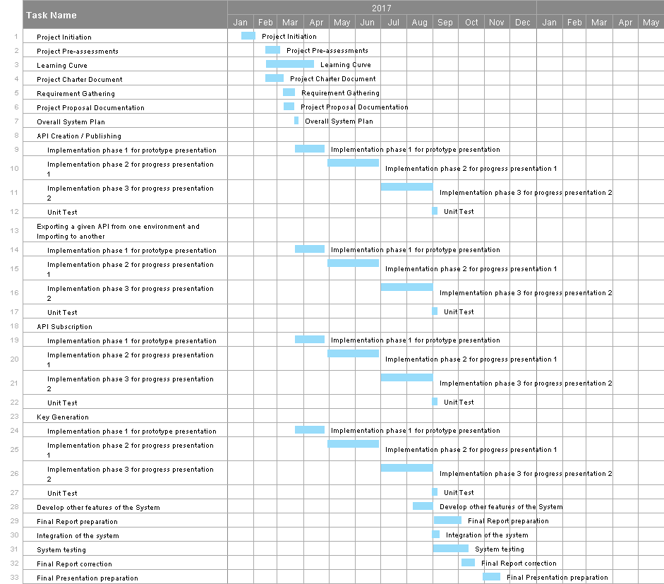

## Appendix – B: Work Breakdown Structure

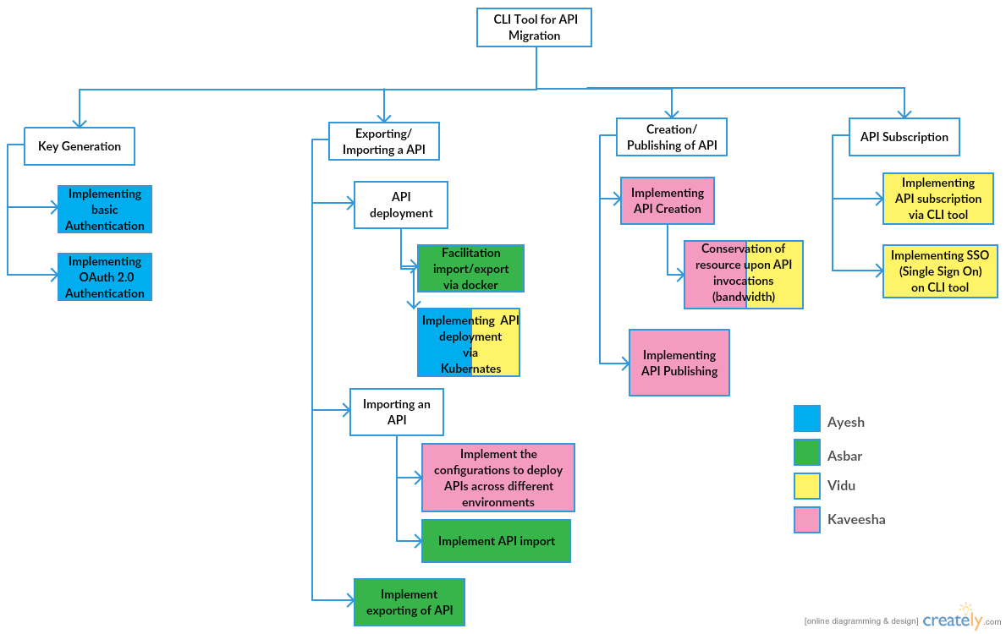

## Appendix – C: Feedback by industry experts

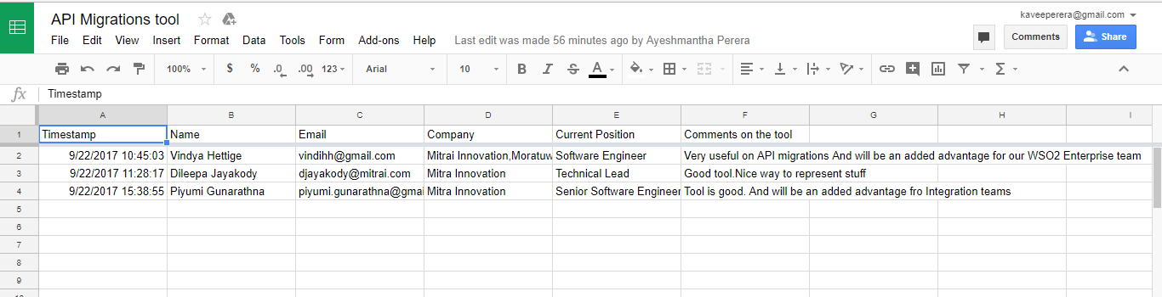

## Appendix – D: Sequence Diagrams

### Overall sequence diagram for the system

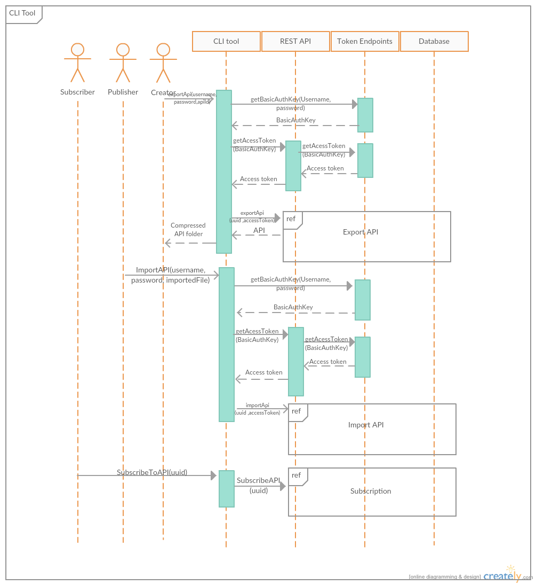

### Sequence diagram for import functionality

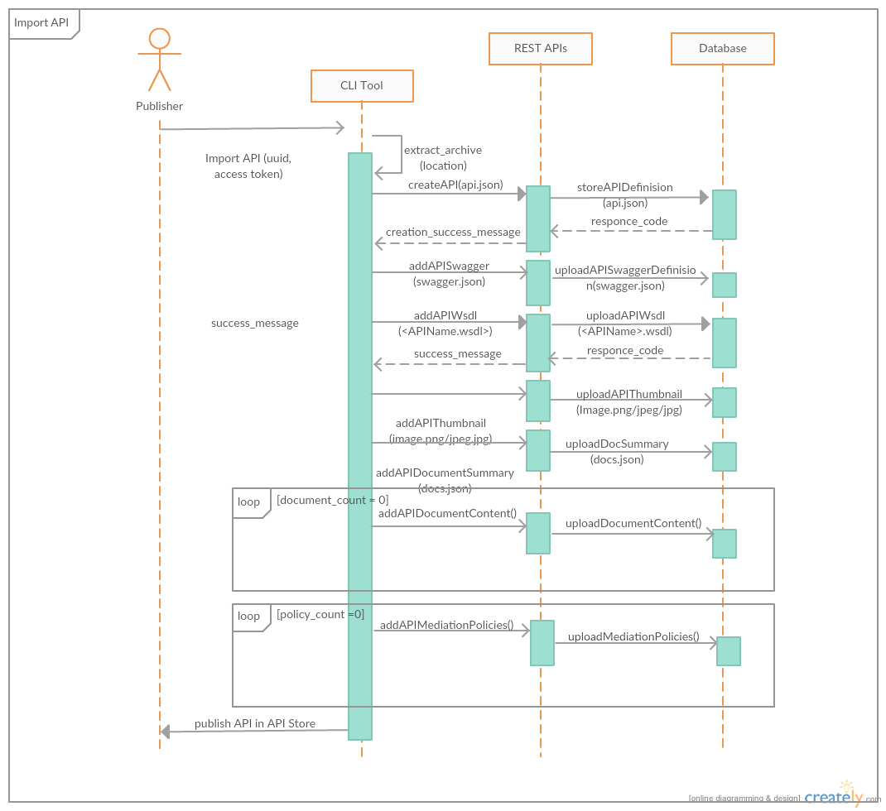

### Sequence diagram fragment for export functionality.

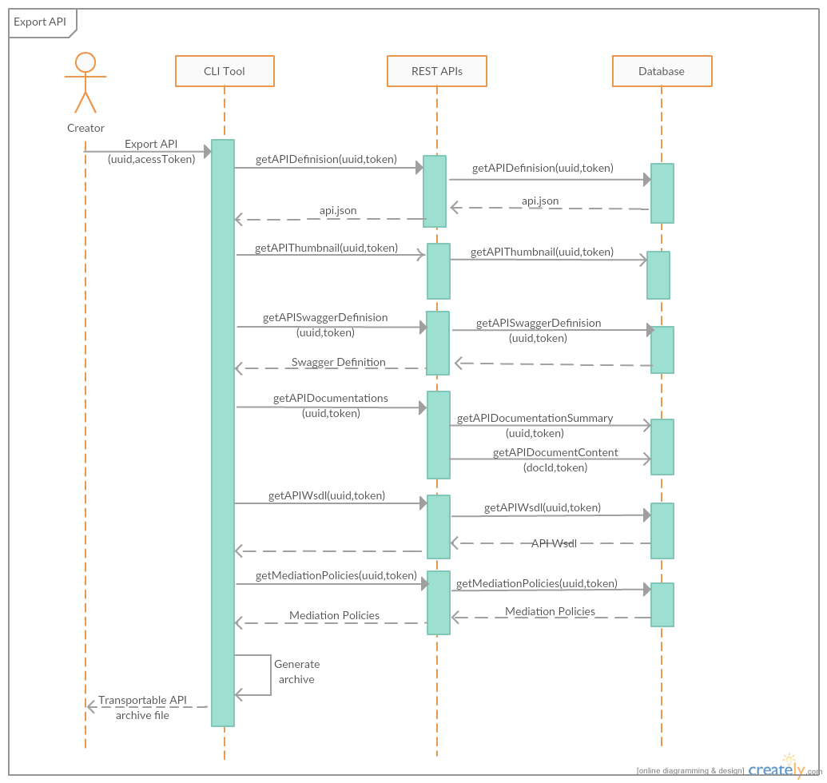

## Appendix – E: Class Diagram for the overall system

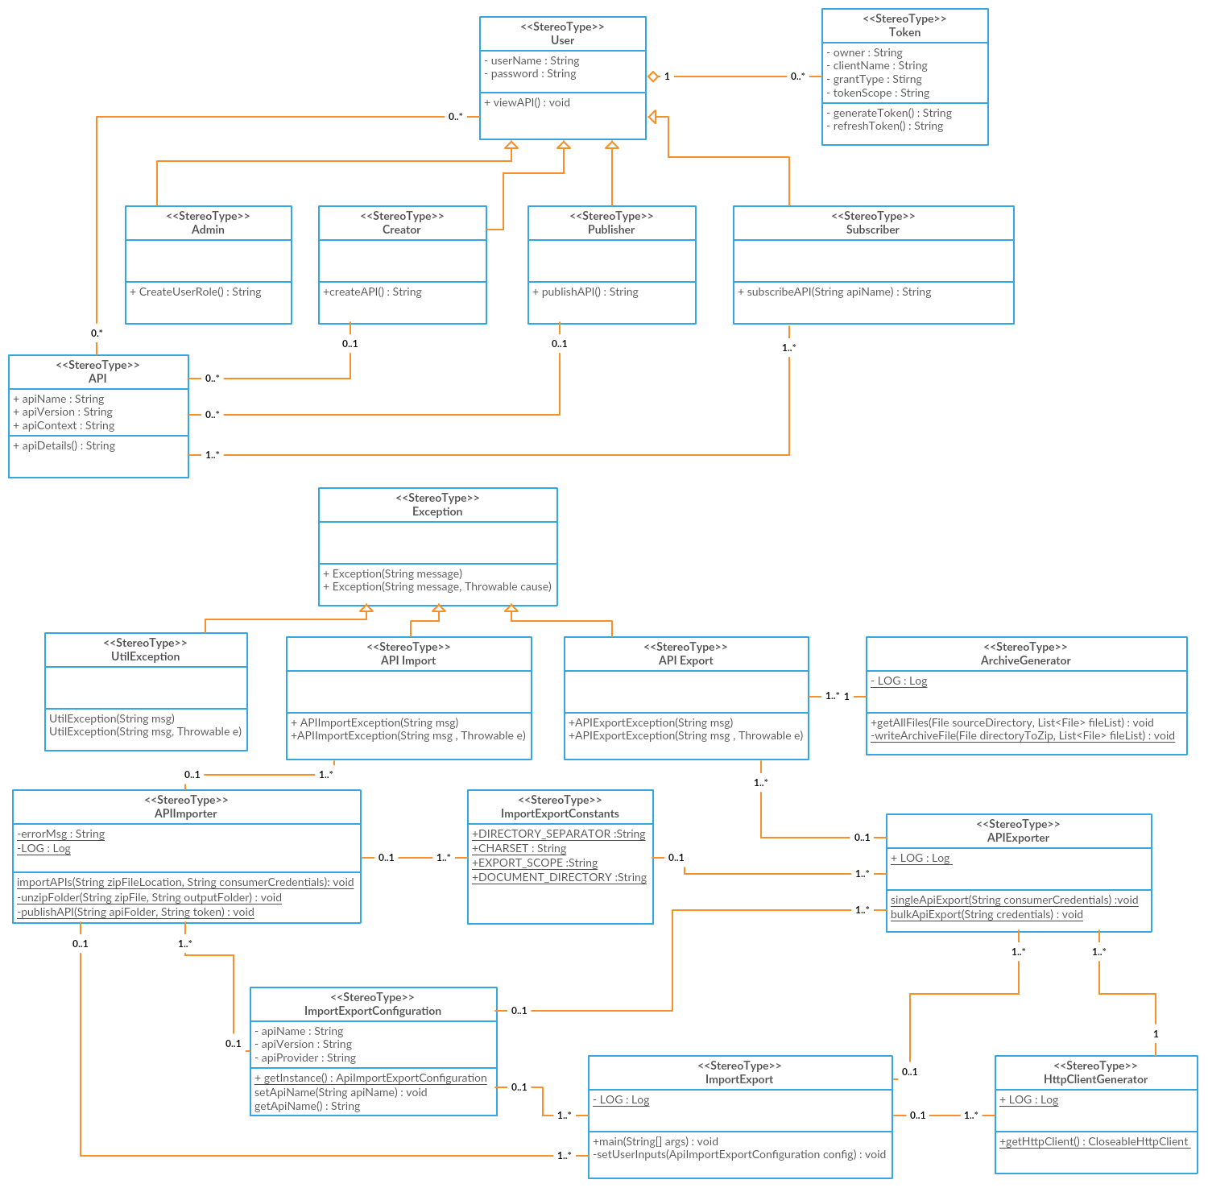

## Appendix – F: Activity Diagram for the overall system

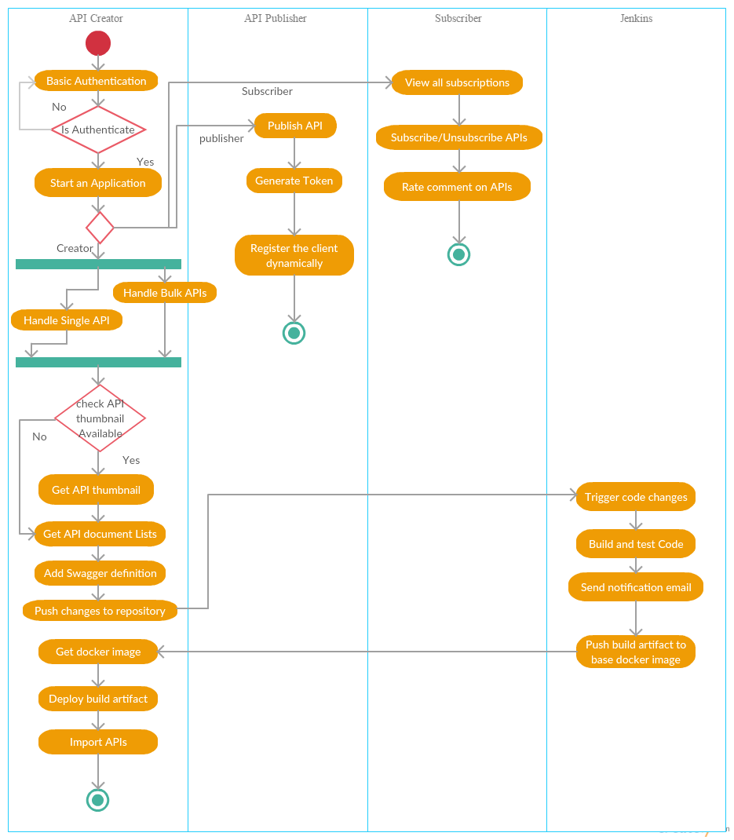

# SUMMARY

Now a days IT industry growing like no time. API’s are doing incredible work on making this realistic. All the ongoing projects in the IT field (Most of the newly started ones around 2015) are now having a service layer which will decouple the backend from the whole front end and from the project which will make the help to modularize and containerize the application and work with the micro services.

The research will have based on the API Managers. Which will be a day to day life for a developer to work on. As per the client request most probably they have to make more effort to configure and handle the API’s on various platforms. But throughout the powerful CLI tool that will be the final outcome of this research will make it easier for them. It will be only a one click work for the developers.

The CLI tool will cover all the main tasks that will be handled through the APIM tools. And also, will give one command deployment through the CLI tool with use of Kubernates. And also automate most of the manual tasks that are in progress of many APIM